Lenin on Social Chauvinists
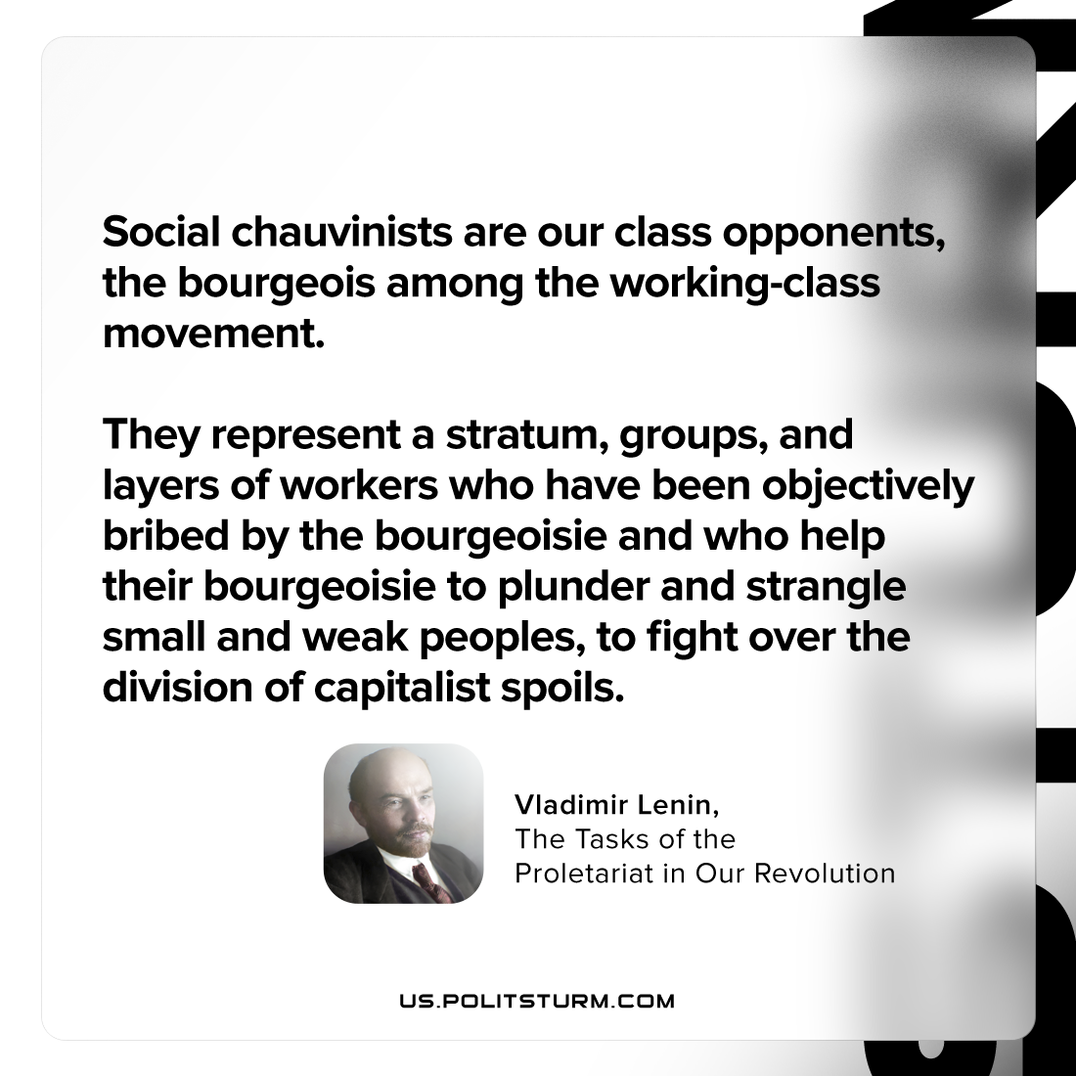

Original article
2023-06-11

"Social chauvinists are our class opponents, the bourgeois among the working-class movement. They represent a stratum, groups, and layers of workers who have been objectively bribed by the bourgeoisie and who help their bourgeoisie to plunder and strangle small and weak peoples, to fight over the division of capitalist spoils"
Vladimir Lenin, The Tasks of the Proletariat in Our Revolution

Original article

