Lenin on Slavery and Freedom
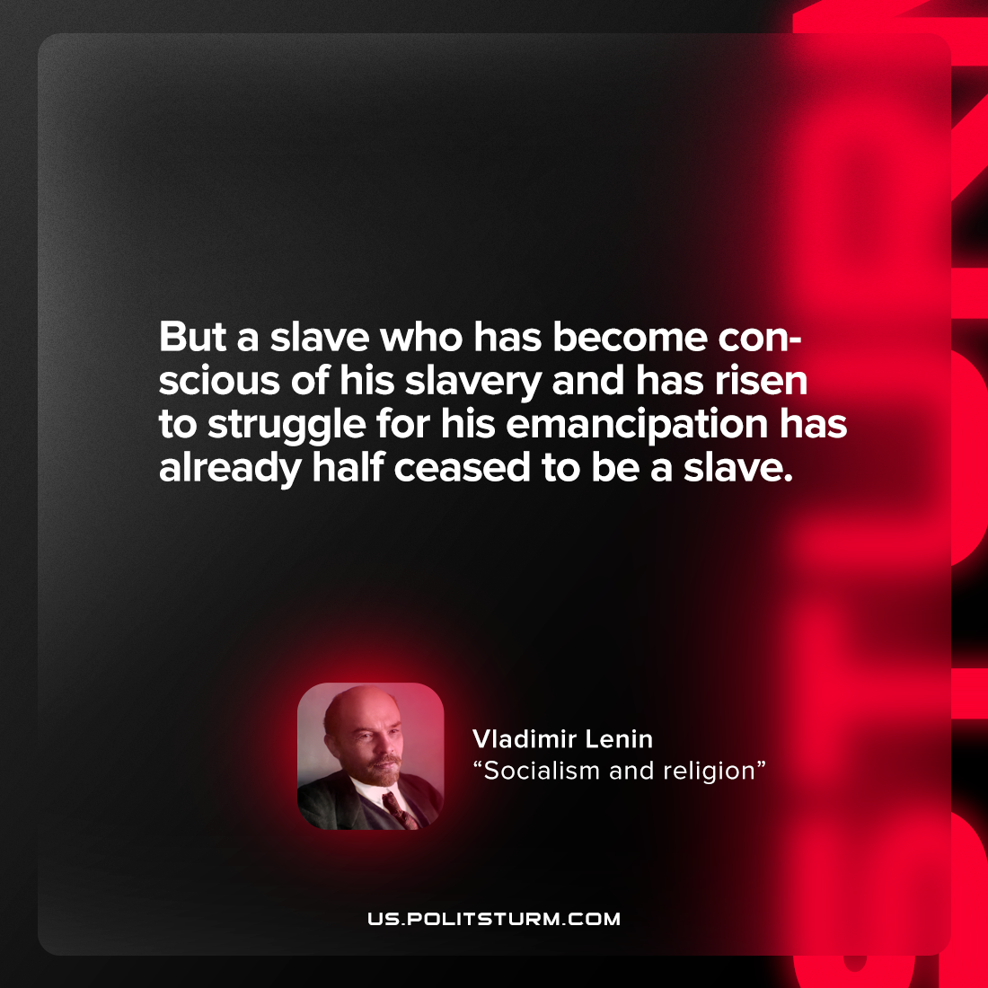

Original article
2022-07-04

But a slave who has become conscious of his slavery and has risen to struggle for his emancipation has already half ceased to be a slave.
V. I. Lenin, “Socialism and Religion”

Original article

