Lenin on Revolutions
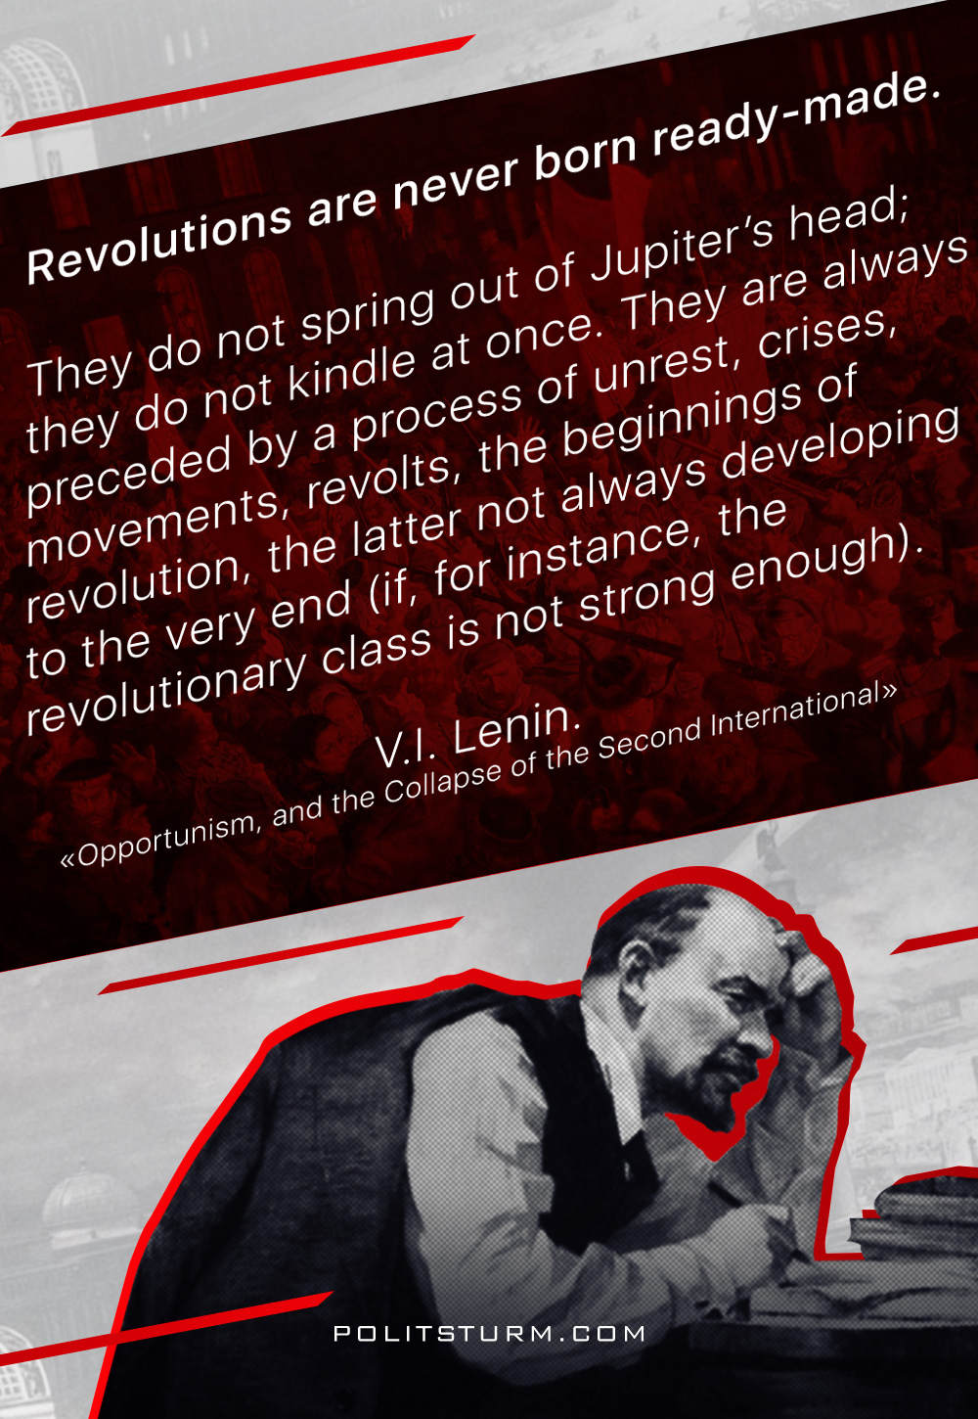

Original article
2018-07-08

“Revolutions are never born ready-made; they do not spring out of Jupiter’s head; they do not kindle at once. They are always preceded by a process of unrest, crises, movements, revolts, the beginnings of revolution, the latter not always developing to the very end (if, for instance, the revolutionary class is not strong enough).”
V.I. Lenin, “Opportunism, and the Collapse of the Second International”

Original article

