Lenin on Revolutions
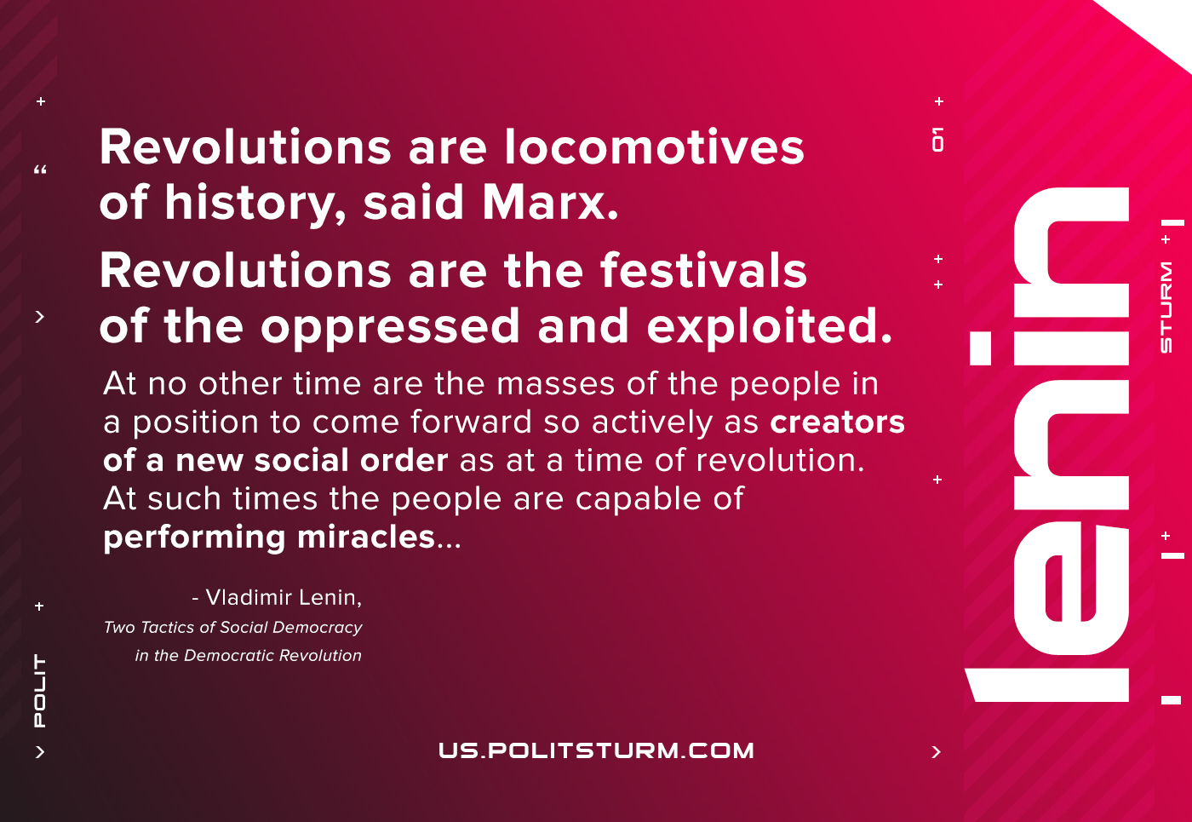

Original article
2021-05-16

Revolutions are the locomotives of history, said Marx. Revolutions are the festivals of the oppressed and the exploited. At no other time are the masses of the people in a position to come forward so actively as creators of a new social order as at a time of revolution. At such times the people are capable of performing miracles, if judged by the narrow, philistine scale of gradual progress.
Vladimir Lenin, Two Tactics of Social-Democracy in the Democratic Revolution

Original article

