Lenin on Revolutions
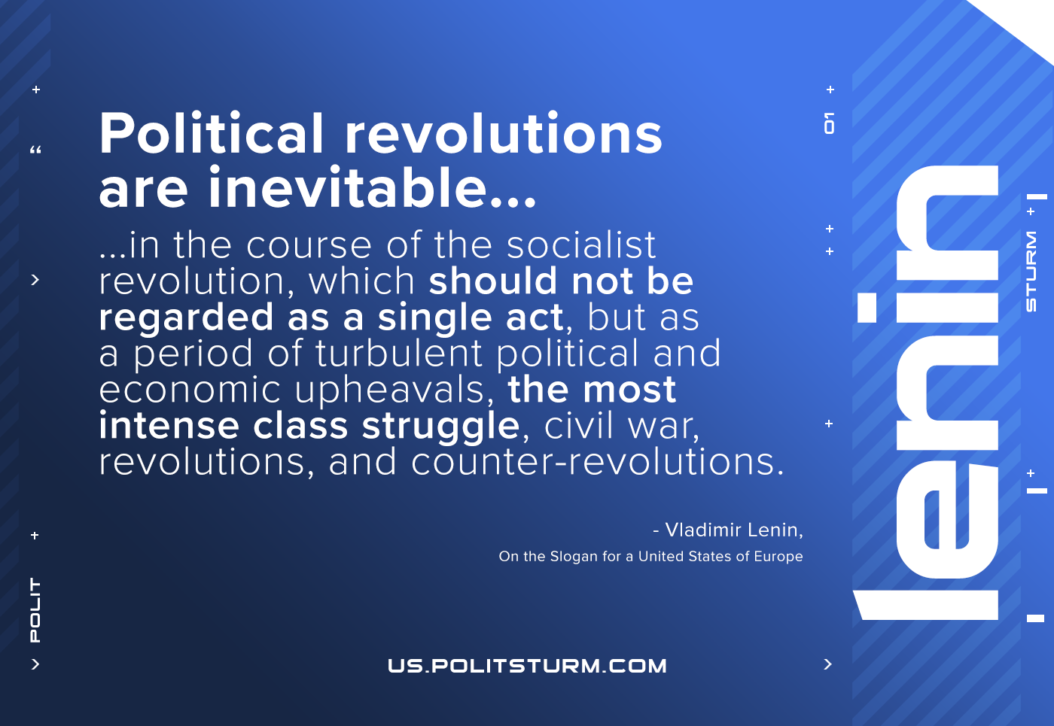

Original article
2021-04-24

Political revolutions are inevitable in the course of the socialist revolution, which should not be regarded as a single act, but as a period of turbulent political and economic upheavals, the most intense class struggle, civil war, revolutions, and counter-revolutions.
On the Slogan for the United States of Europe

Original article

