Lenin on Revolutionary Energy and Dictatorship of the Proletariat
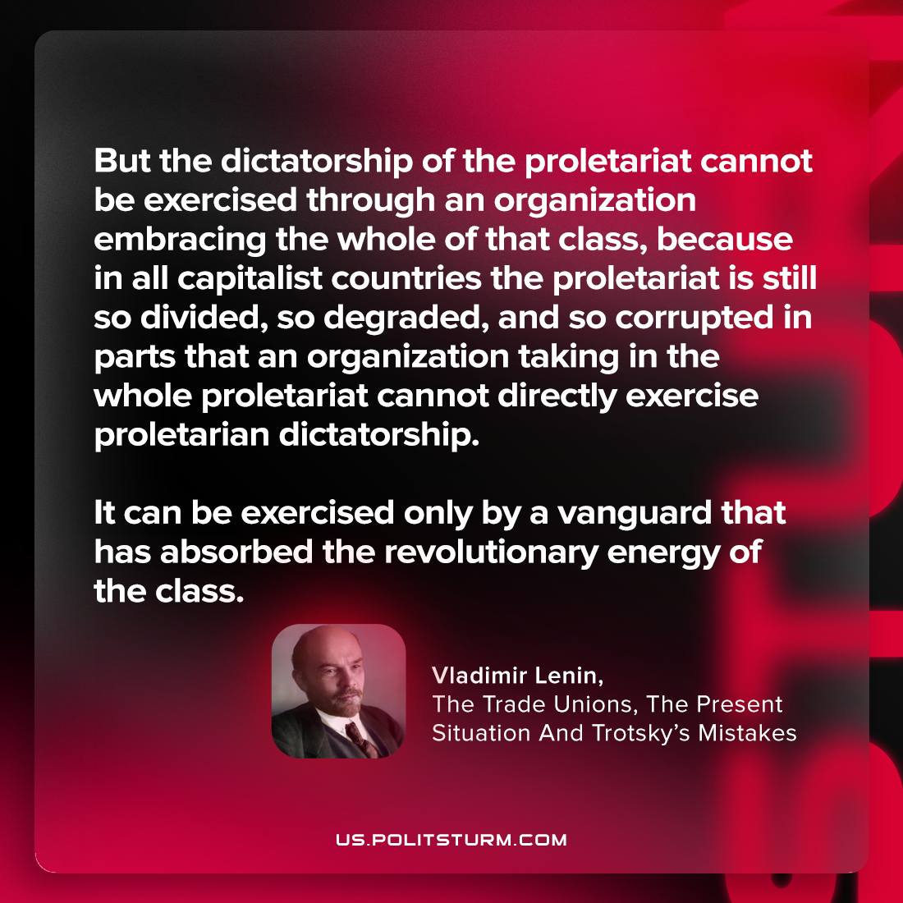

Original article
2023-06-25

"But the dictatorship of the proletariat cannot be exercised through an organization embracing the whole of that class, because in all capitalist countries… the proletariat is still so divided, so degraded, and so corrupted in parts… that an organization taking in the whole proletariat cannot directly exercise proletarian dictatorship. It can be exercised only by a vanguard that has absorbed the revolutionary energy of the class."
Vladimir Lenin, The Trade Unions, The Present Situation And Trotsky’s Mistakes

Original article

