Lenin on Revolution
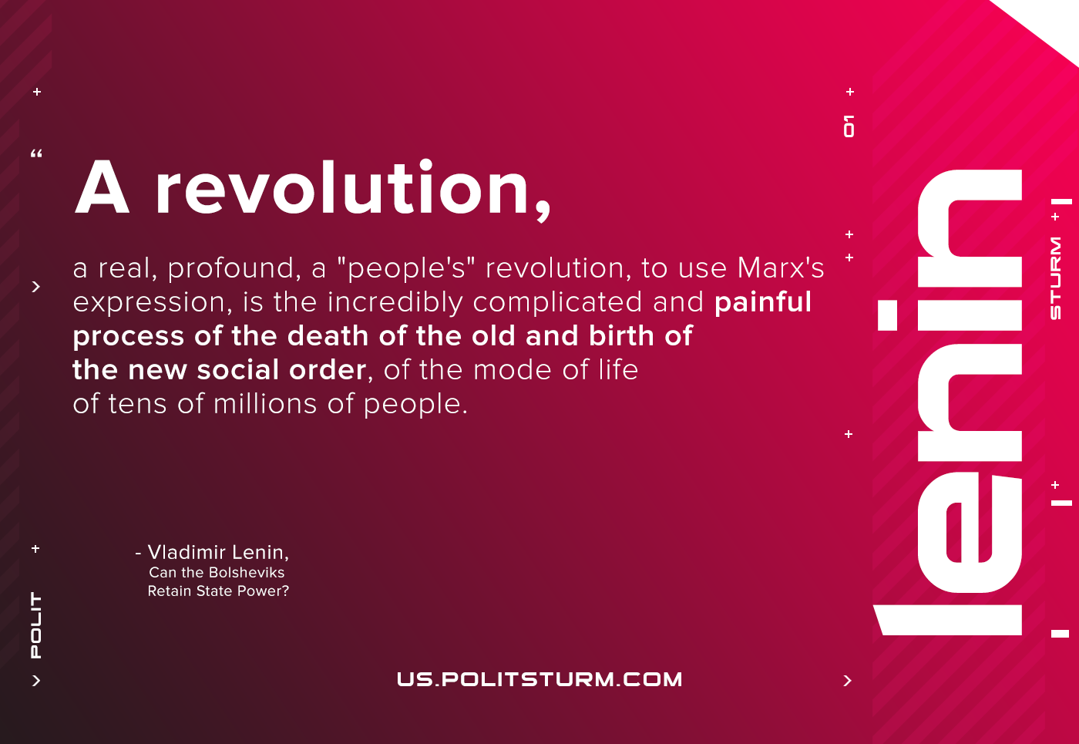

Original article
2020-11-14

A revolution, a real, profound, a “people’s” revolution, to use Marx’s expression, is the incredibly complicated and painful process of the death of the old and birth of the new social order, of the mode of life of tens of millions of people.
Vladimir Lenin
Can the Bolsheviks Retain State Power?

Original article

