Lenin on Religion and Class-Consciousness
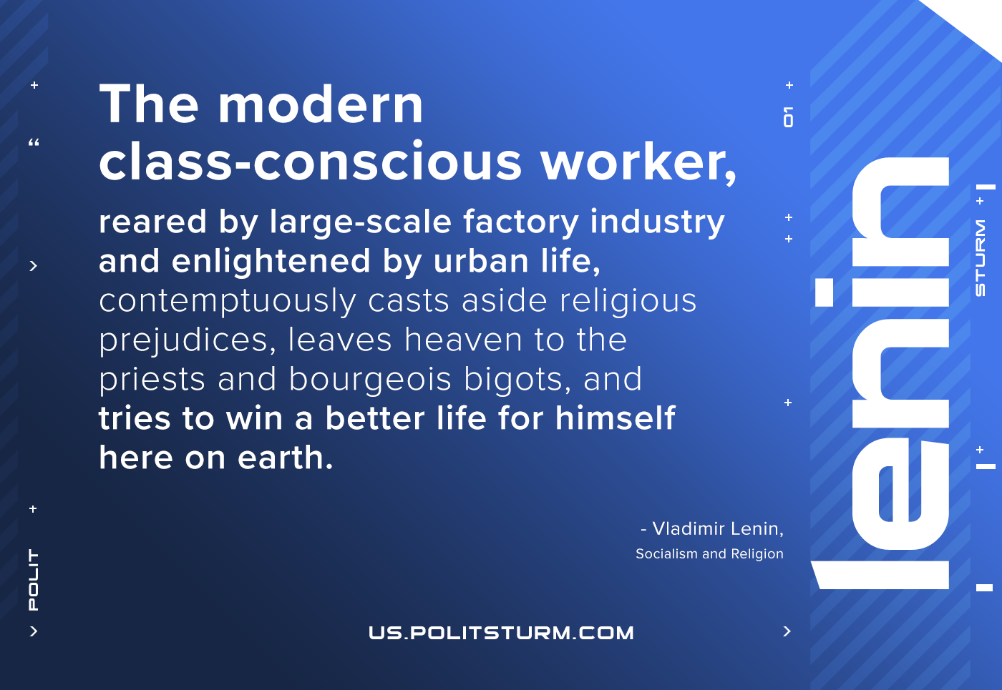

Original article
2021-04-21

The modern class-conscious worker, reared by large-scale factory industry and enlightened by urban life, contemptuously casts aside religious prejudices, leaves heaven to the priests and bourgeois bigots, and tries to win a better life for himself here on earth.
Socialism and Religion

Original article

