Lenin on Religion
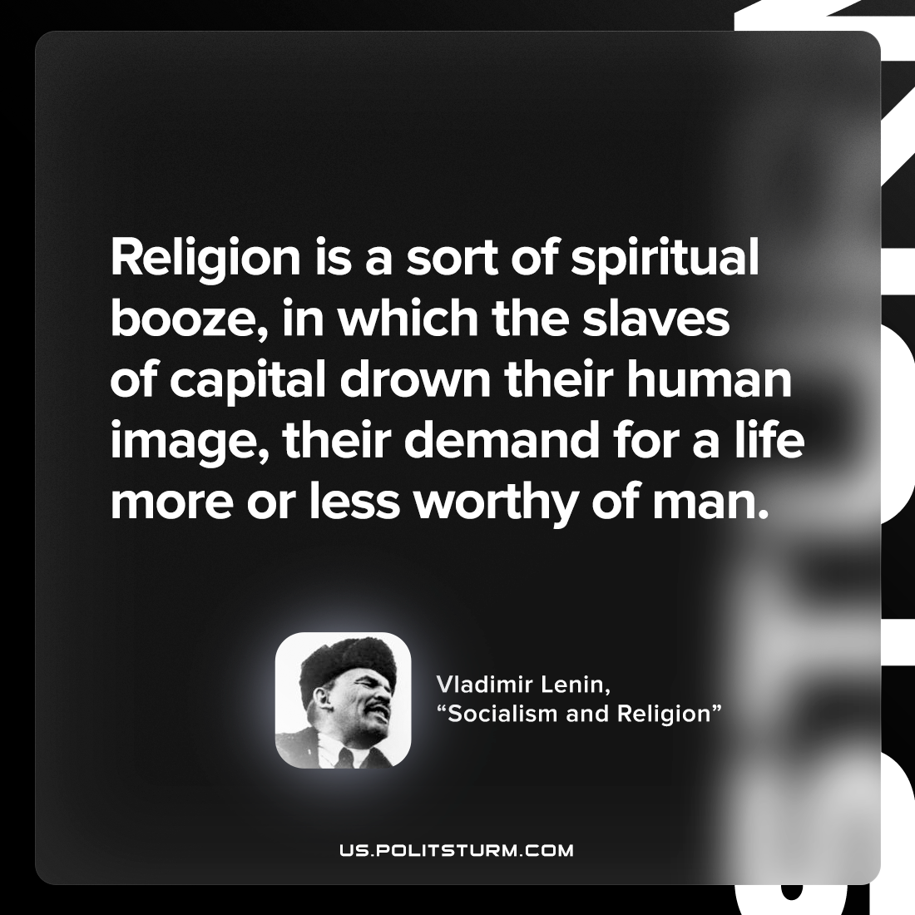

Original article
2022-07-29

Religion is a sort of spiritual booze, in which the slaves of capital drown their human image, their demand for a life more or less worthy of man.

Vladimir Lenin, “Socialism and religion”

Original article

