Lenin on Reformism
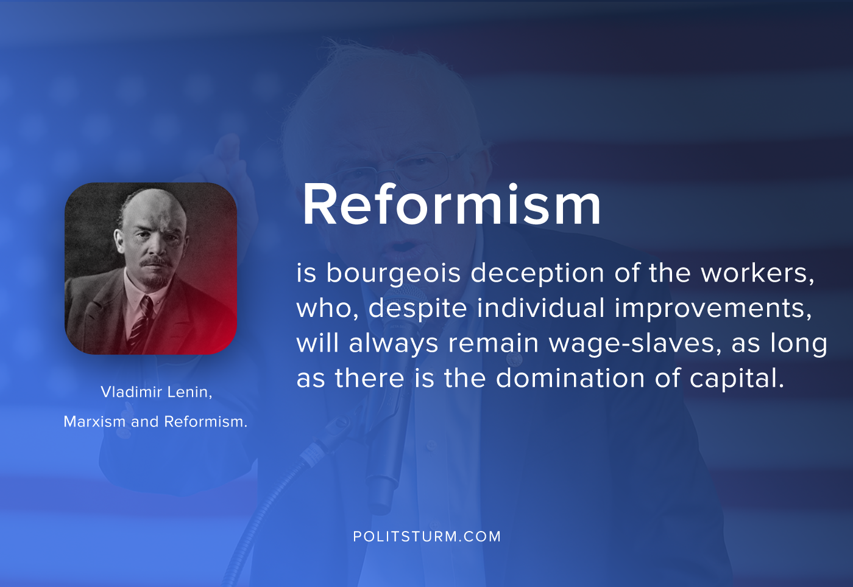

Original article
2020-07-22

Reformism is bourgeois deception of the workers, who, despite individual improvements, will always remain wage-slaves, as long as there is the domination of capital.
Vladimir Lenin, “Marxism and Reformism”

Original article

