Lenin on Proletarian Unity Gained Against Opportunism
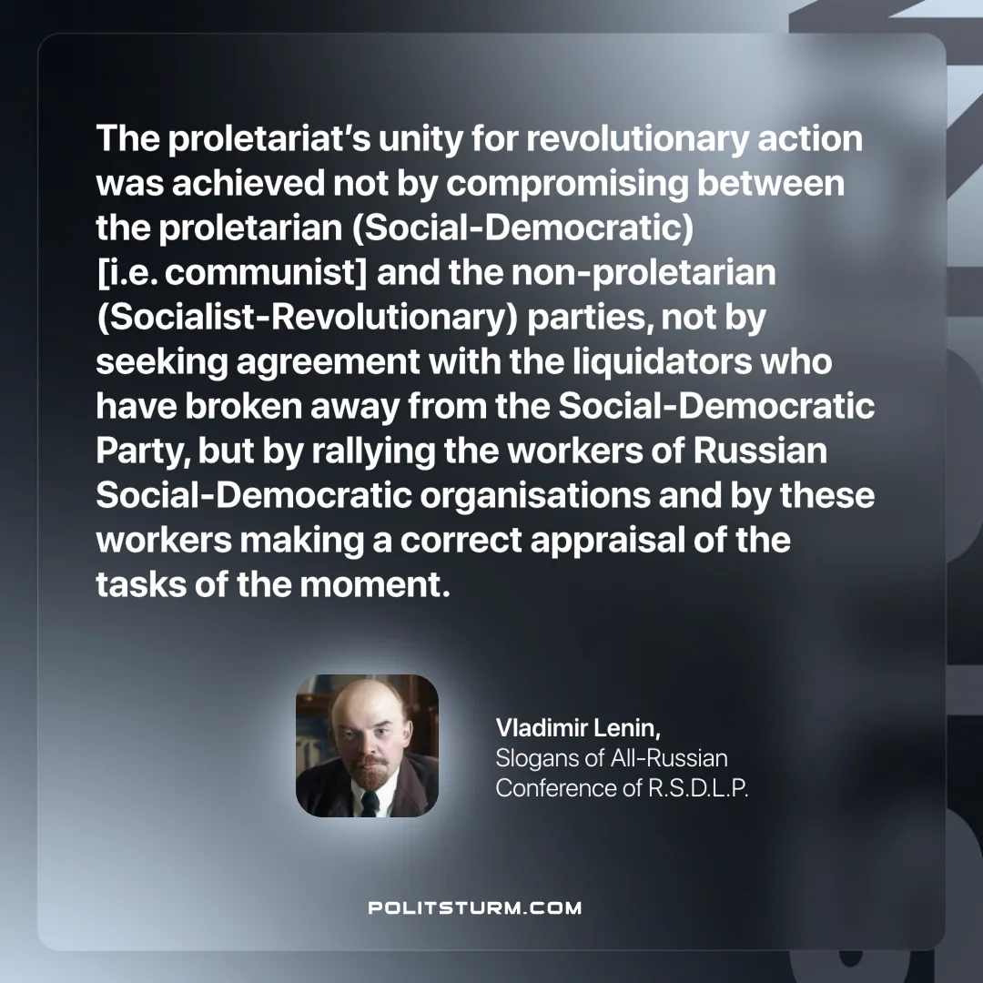

Original article
2025-03-08

"The proletariat’s unity for revolutionary action was achieved not by compromising between the proletarian (Social-Democratic) [i.e. communist] and the non-proletarian (Socialist-Revolutionary) parties, not by seeking agreement with the liquidators who have broken away from the Social-Democratic Party, but by rallying the workers of Russian Social-Democratic organisations and by these workers making a correct appraisal of the tasks of the moment."
Vladimir Lenin, Slogans of All-Russian Conference of R.S.D.L.P.

Original article

