Lenin on Proletarian Economy
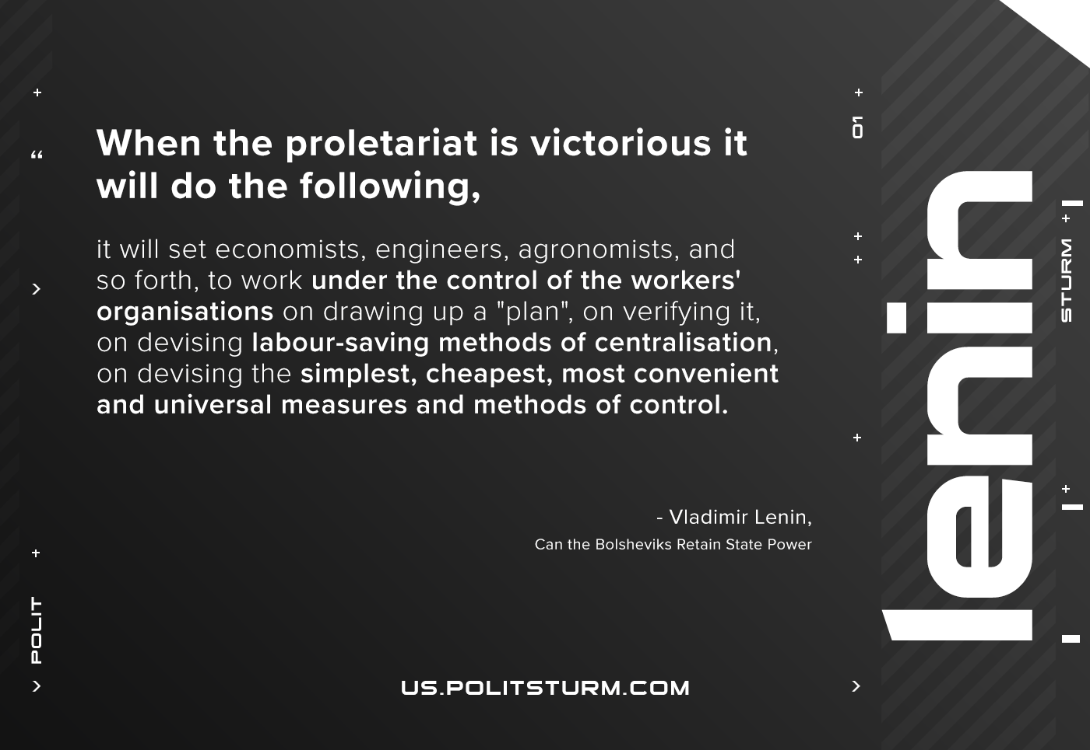

Original article
2021-01-18

When the proletariat is victorious it will do the following, it will set economists, engineers, agronomists, and so forth, to work under the control of the workers’ organizations on drawing up a “plan”, on verifying it, on devising labor-saving methods of centralization, on devising the simplest, cheapest, most convenient and universal measures and methods of control.
Vladimir Lenin, “Can the Bolsheviks Retain State Power?”

Original article

