Lenin on "Practicality" Subordinating the Workers to the Capitalist
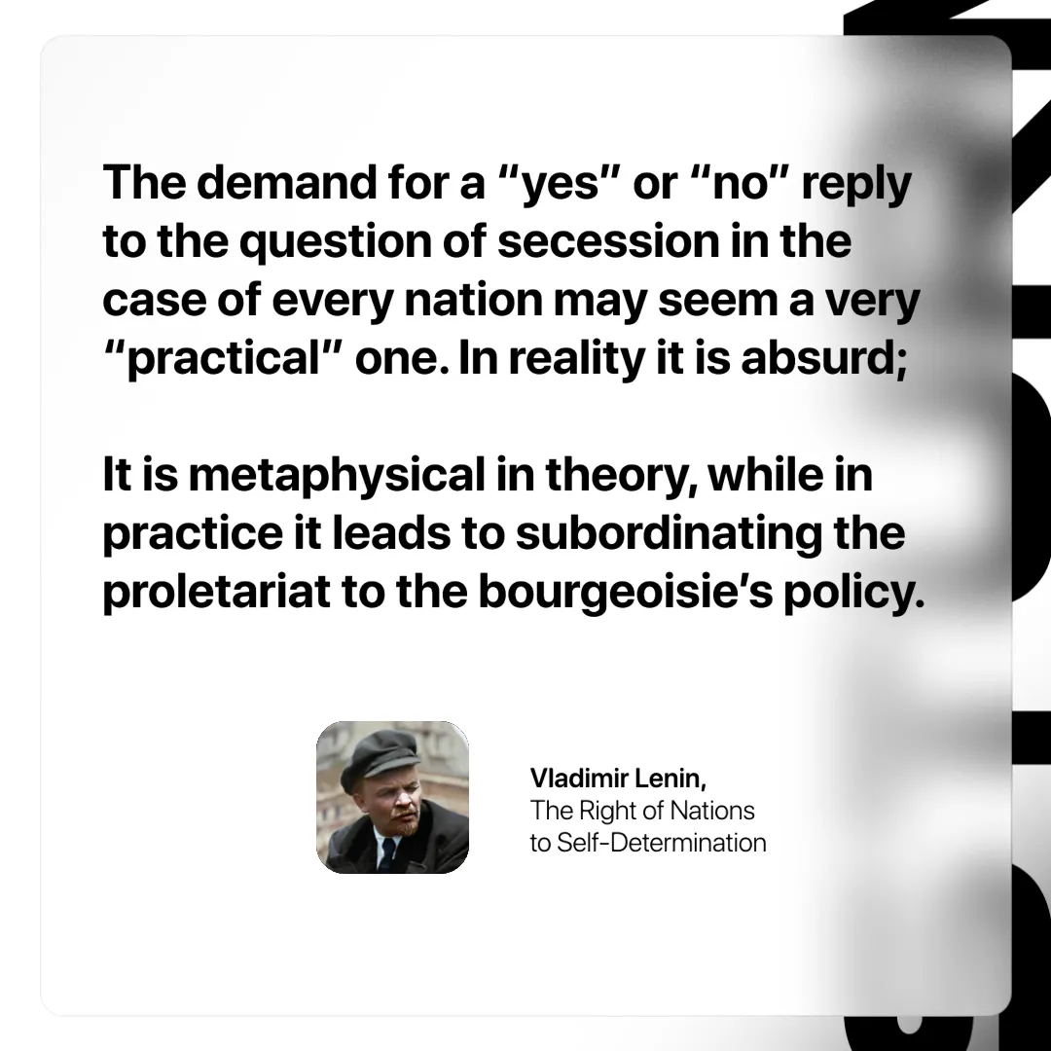

Original article
2024-12-21

“The demand for a “yes” or “no” reply to the question of secession in the case of every nation may seem a very “practical” one. In reality it is absurd; it is metaphysical in theory, while in practice it leads to subordinating the proletariat to the bourgeoisie’s policy.”
Vladimir Lenin, The Right of Nations to Self-Determination

Original article

