Lenin on the Politics of Russia
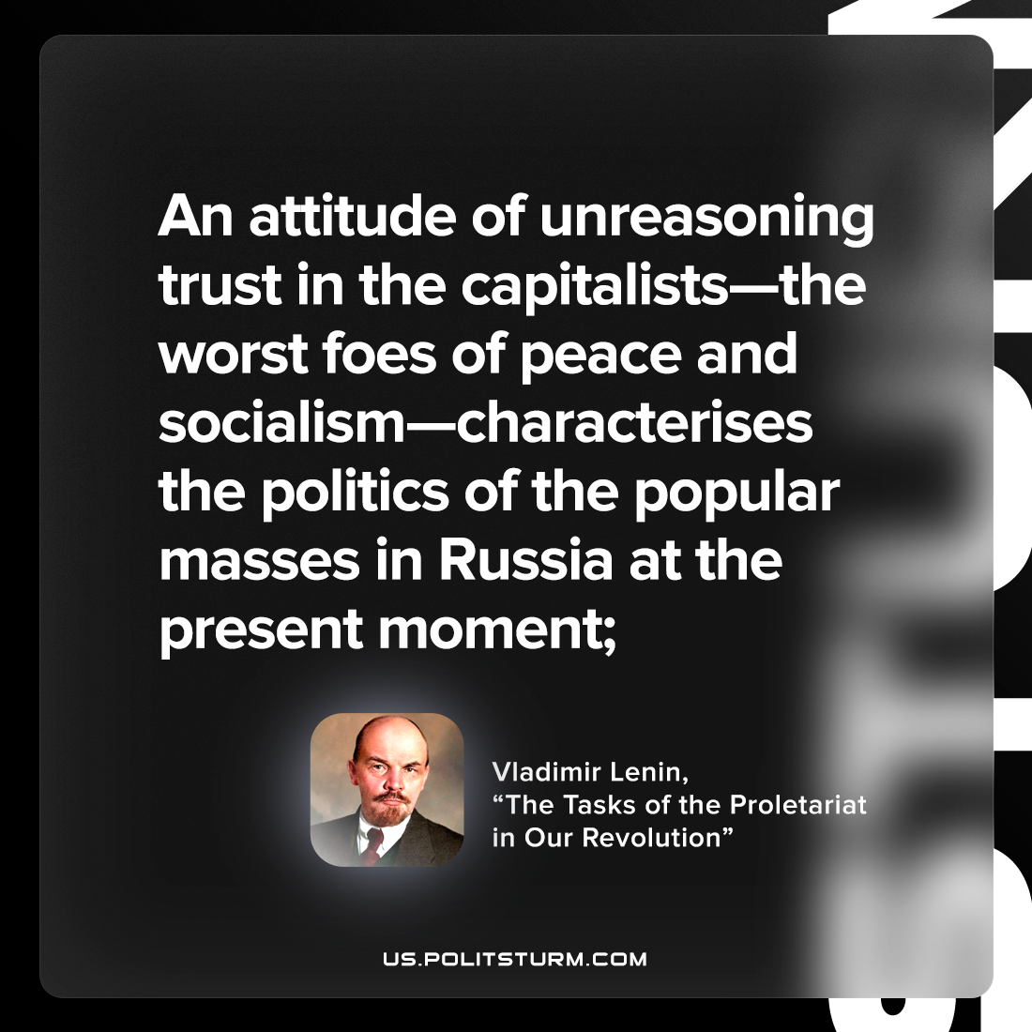

Original article
2022-08-28

An attitude of unreasoning trust in the capitalists—the worst foes of peace and socialism—characterises the politics of the popular masses in Russia at the present moment;
Vladimir Lenin, “The Tasks of the Proletariat in Our Revolution”

Original article

