Lenin on People's Freedom
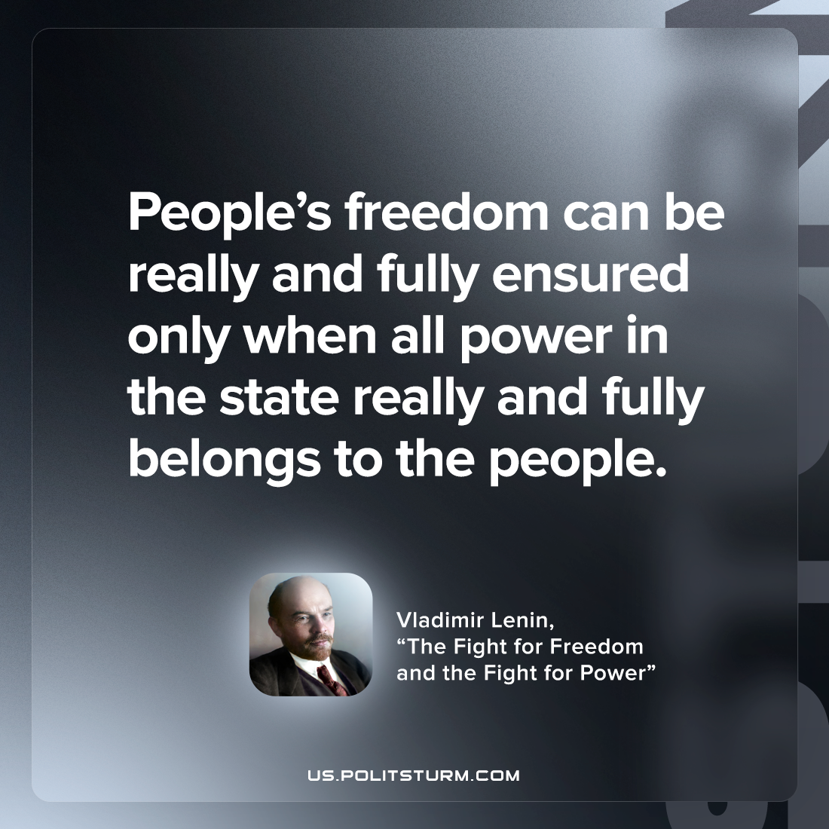

Original article
2022-08-10

People’s freedom can be really and fully ensured only when all power in the state really and fully belongs to the people.

Vladimir Lenin, “The Fight for Freedom and the Fight for Power”

Original article

