Lenin on Peaceful Assumption of Power
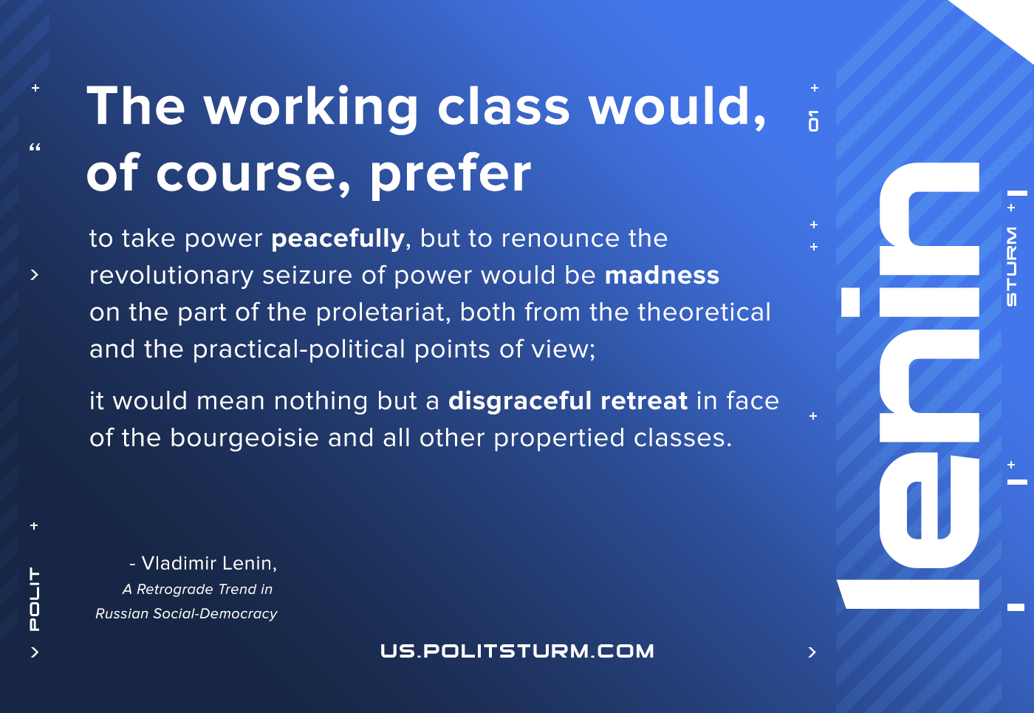

Original article
2021-02-09
1 min read

The working class would, of course, prefer to take power peacefully (we have already stated that this seizure of power can be carried out only by the organized working class which has passed through the school of the class struggle), but to renounce the revolutionary seizure of power would be madness on the part of the proletariat, both from the theoretical and the practical-political points of view; it would mean nothing but a disgraceful retreat in face of the bourgeoisie and all other propertied classes.

Vladimir Lenin, A Retrograde Trend in Russian Social-Democracy

Original article

