Lenin on Peace
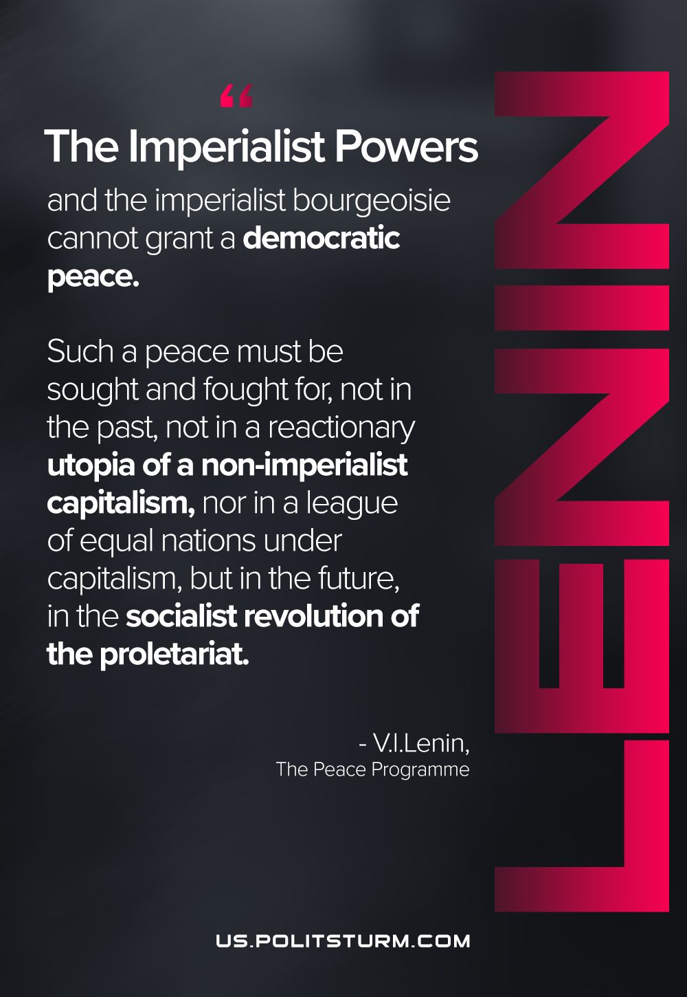

Original article
2021-05-27

The imperialist Powers and the imperialist bourgeoisie cannot grant a democratic peace. Such a peace must be sought and fought for, not in the past, not in a reactionary utopia of a non-imperialist capitalism, nor in a league of equal nations under capitalism, but in the future, in the socialist revolution of the proletariat.
Lenin, The Peace Programme

Original article

