Lenin on Peace Without the Struggle for Socialism
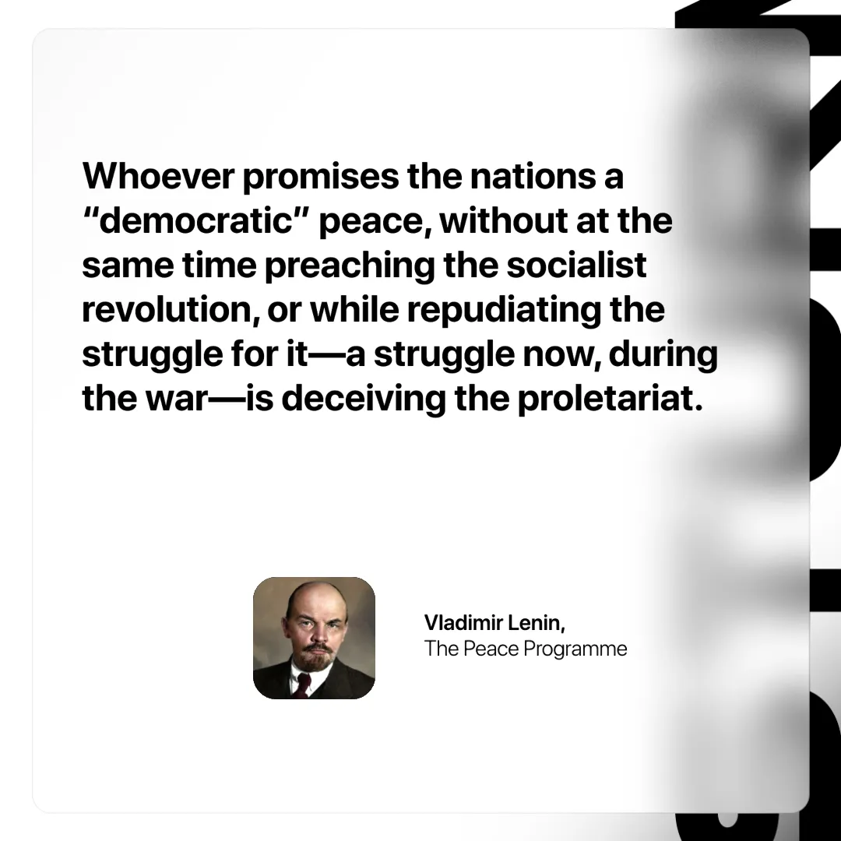

Original article
2025-05-24

“Whoever promises the nations a “democratic” peace, without at the same time preaching the socialist revolution, or while repudiating the struggle for it—a struggle now, during the war—is deceiving the proletariat.”
Vladimir Lenin, The Peace Programme

Original article

