Lenin on Peace Under Capitalism
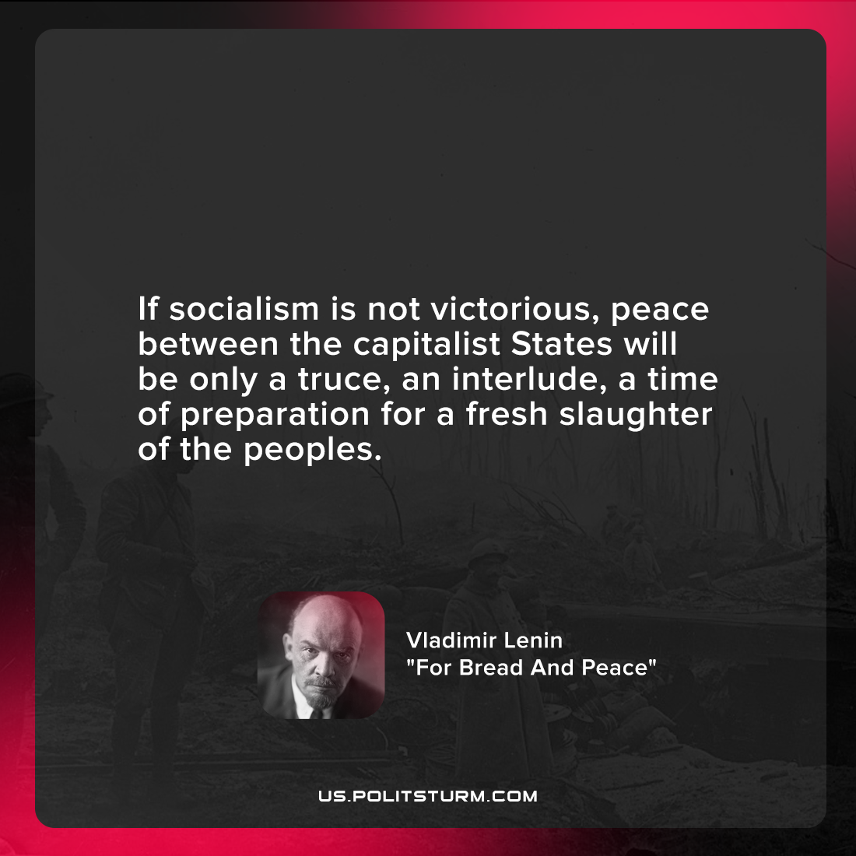

Original article
2022-02-24

If socialism is not victorious, peace between the capitalist States will be only a truce, an interlude, a time of preparation for a fresh slaughter of the peoples.

Vladimir Lenin, “For Bread And Peace”

Original article

