Lenin on Parliamentarism and Democracy
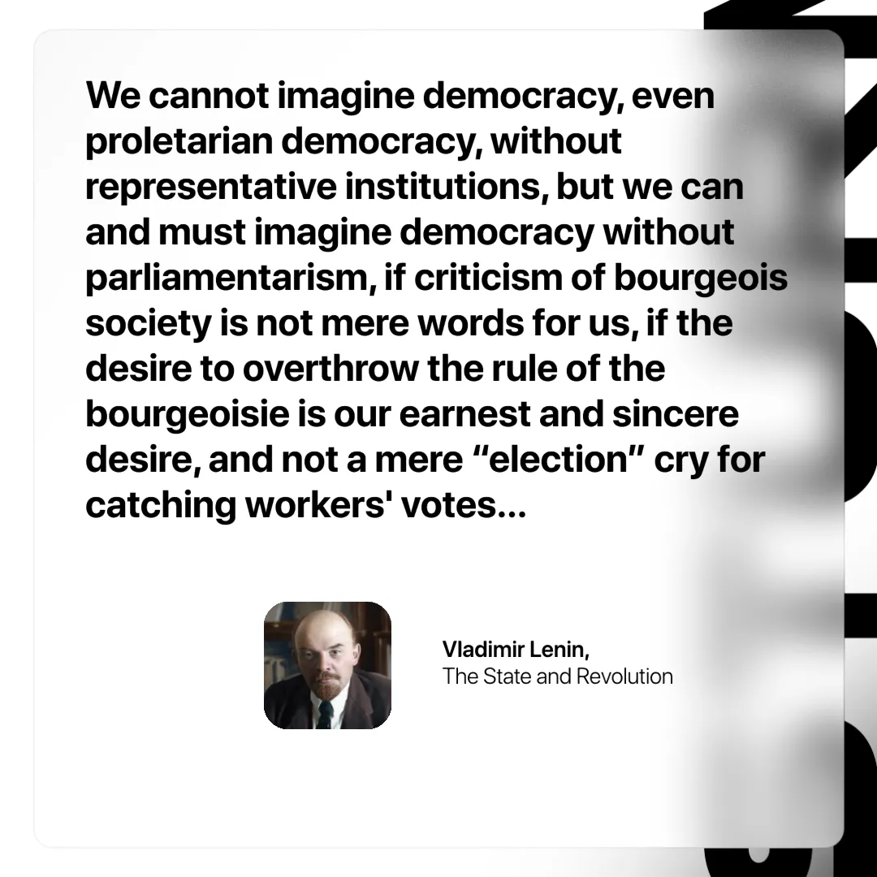

Original article
2024-11-24

“We cannot imagine democracy, even proletarian democracy, without representative institutions, but we can and must imagine democracy without parliamentarism, if criticism of bourgeois society is not mere words for us, if the desire to overthrow the rule of the bourgeoisie is our earnest and sincere desire, and not a mere “election” cry for catching workers' votes…”
Vladimir Lenin, The State and Revolution

Original article

