Lenin on Pacifism
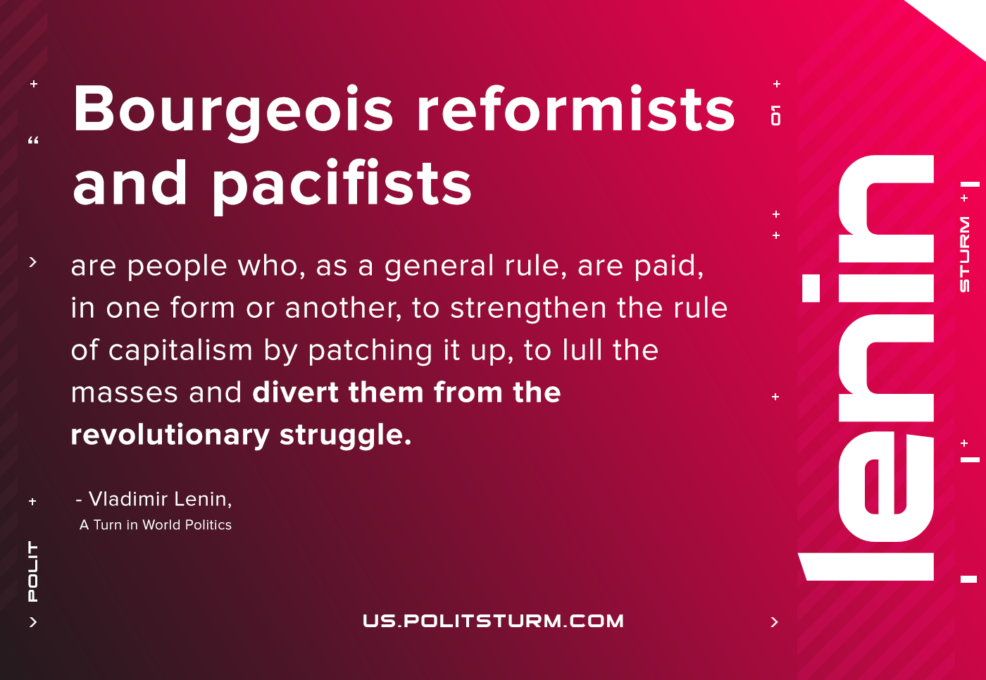

Original article
2020-12-26

Bourgeois reformists and pacifists are people who, as a general rule, are paid, in one form or another, to strengthen the rule of capitalism by patching it up, to lull the masses and divert them from the revolutionary struggle.
Lenin, “A Turn in World Politics”

Original article

