Lenin on Oppressor and Oppressed Nations Under Imperialism
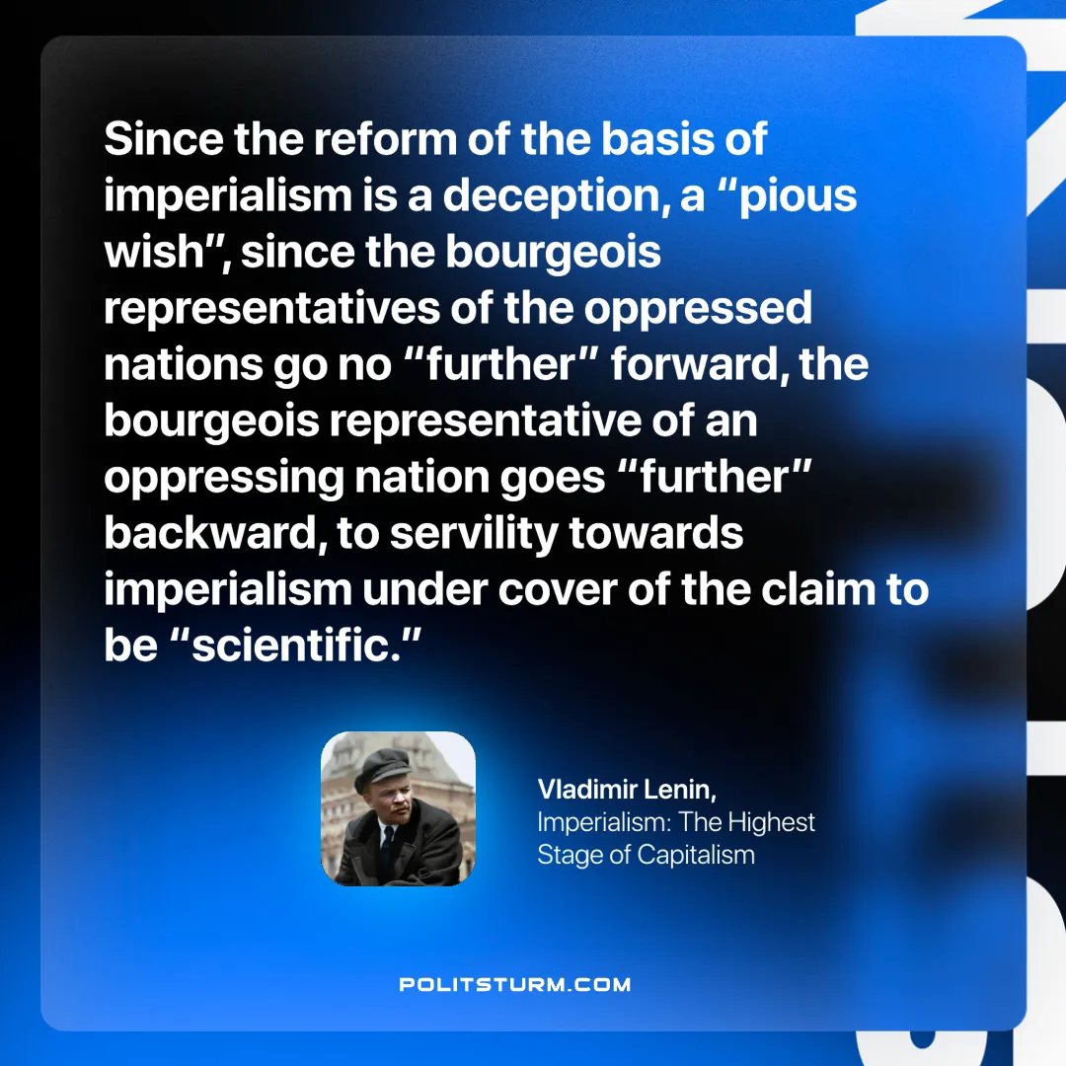

Original article
2024-11-03

“Since the reform of the basis of imperialism is a deception, a “pious wish”, since the bourgeois representatives of the oppressed nations go no “further” forward, the bourgeois representative of an oppressing nation goes “further” backward, to servility towards imperialism under cover of the claim to be “scientific.””
Vladimir Lenin, Imperialism: The Highest Stage of Capitalism

Original article

