Lenin on Opportunists
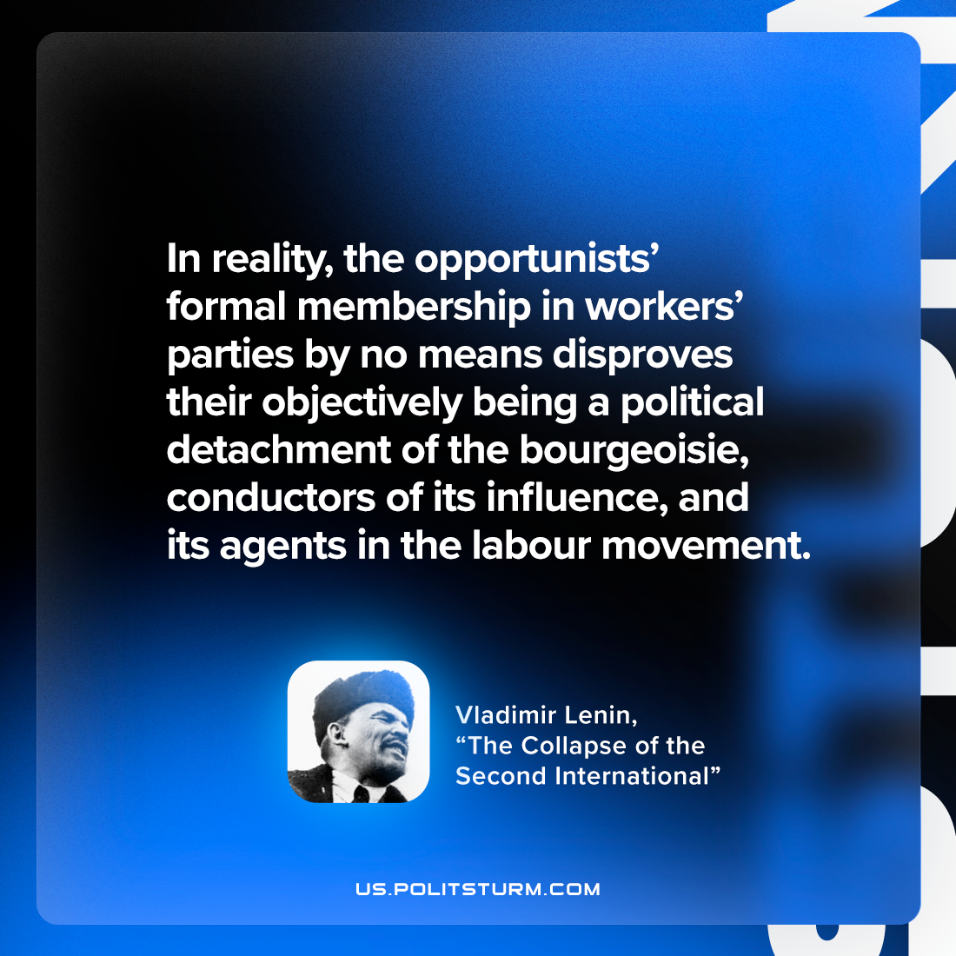

Original article
2023-01-03

"In reality, the opportunists’ formal membership in workers’ parties by no means disproves their objectively being a political detachment of the bourgeoisie, conductors of its influence, and its agents in the labour movement."
Vladimir Lenin, “The Collapse of the Second International”

Original article

