Lenin on Negotiations
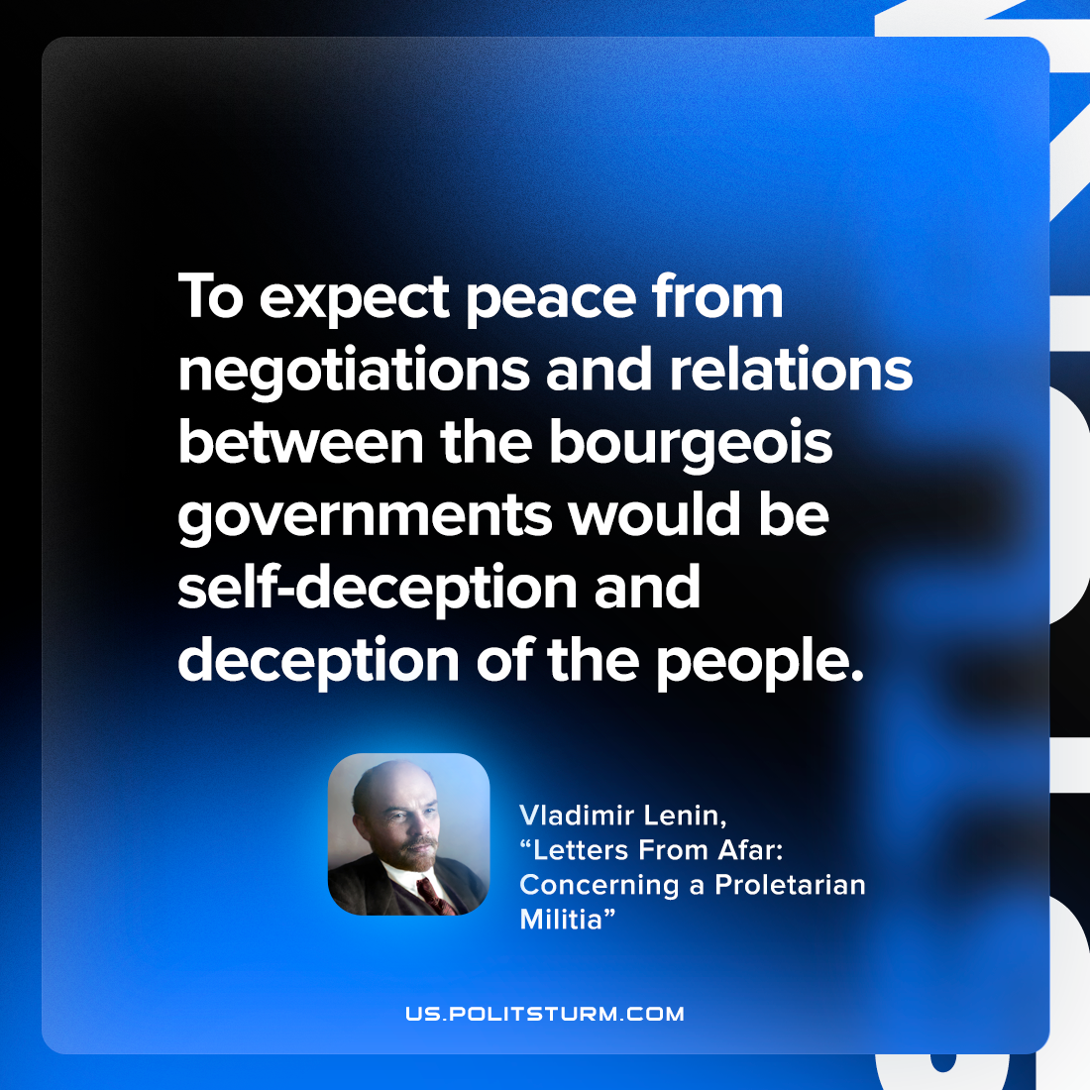

Original article
2022-11-05

To expect peace from negotiations and relations between the bourgeois governments would be self-deception and deception of the people.

Vladimir Lenin, “Letters From Afar: Concerning a Proletarian Militia”

Original article

