Lenin on Nationalist Prejudices
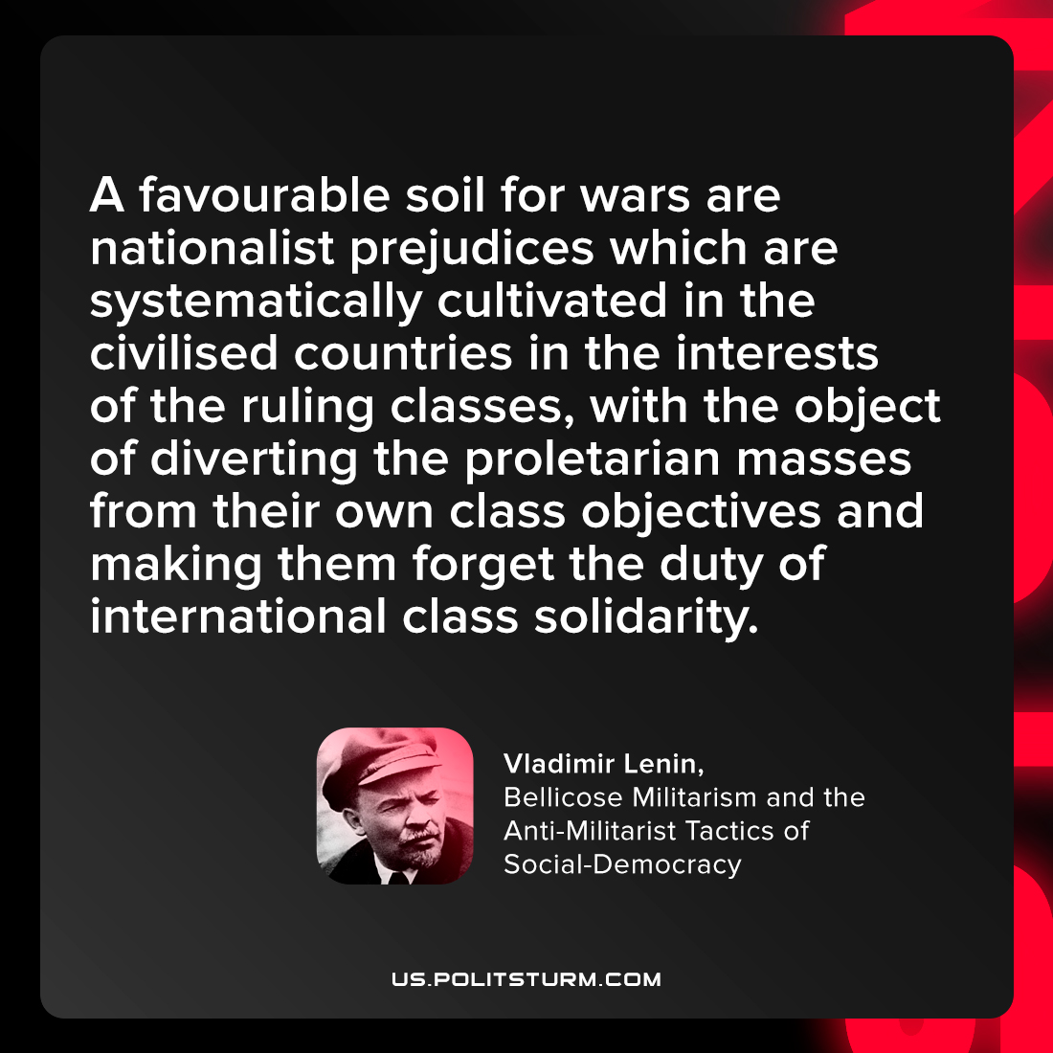

Original article
2022-03-03

A favourable soil for wars are, nationalist prejudices, which are systematically cultivated in the civilised countries in the interests of the ruling classes, with the object of diverting the proletarian masses from their own class objectives arid making them forget the duty of international class solidarity.

Vladimir Lenin, “Bellicose Militarism and the Anti-Militarist Tactics of Social-Democracy”

Original article

