Lenin on Nationalism's Corruption of the Workers
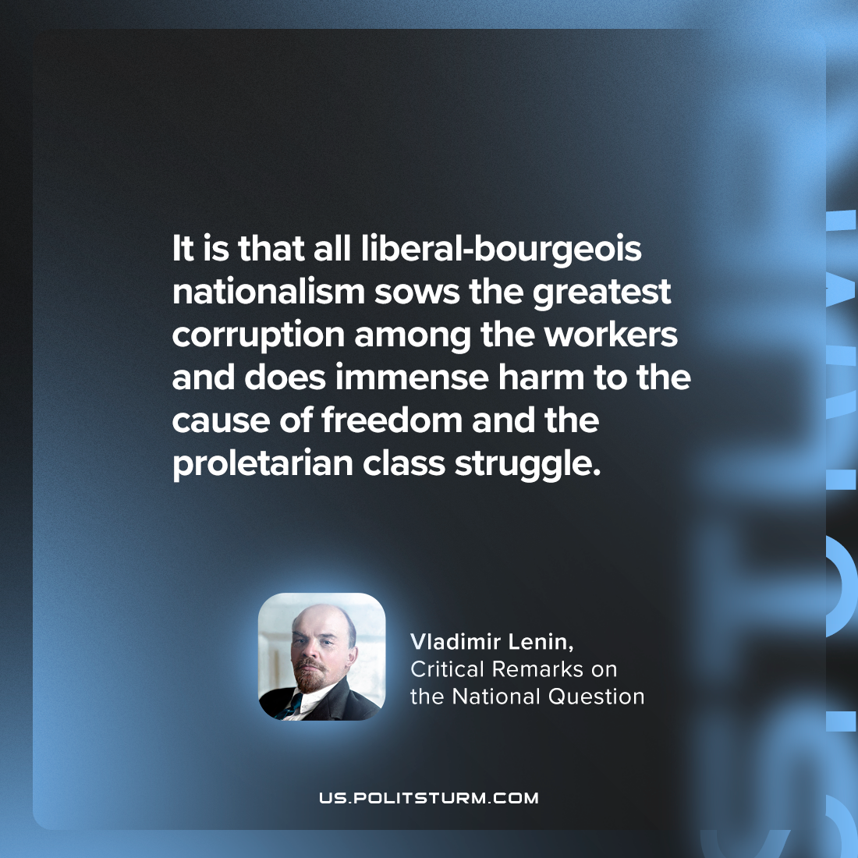

Original article
2024-07-06

"It is that all liberal-bourgeois nationalism sows the greatest corruption among the workers and does immense harm to the cause of freedom and the proletarian class struggle."
Vladimir Lenin, Critical Remarks on the National Question

Original article

