Lenin on Nationalism
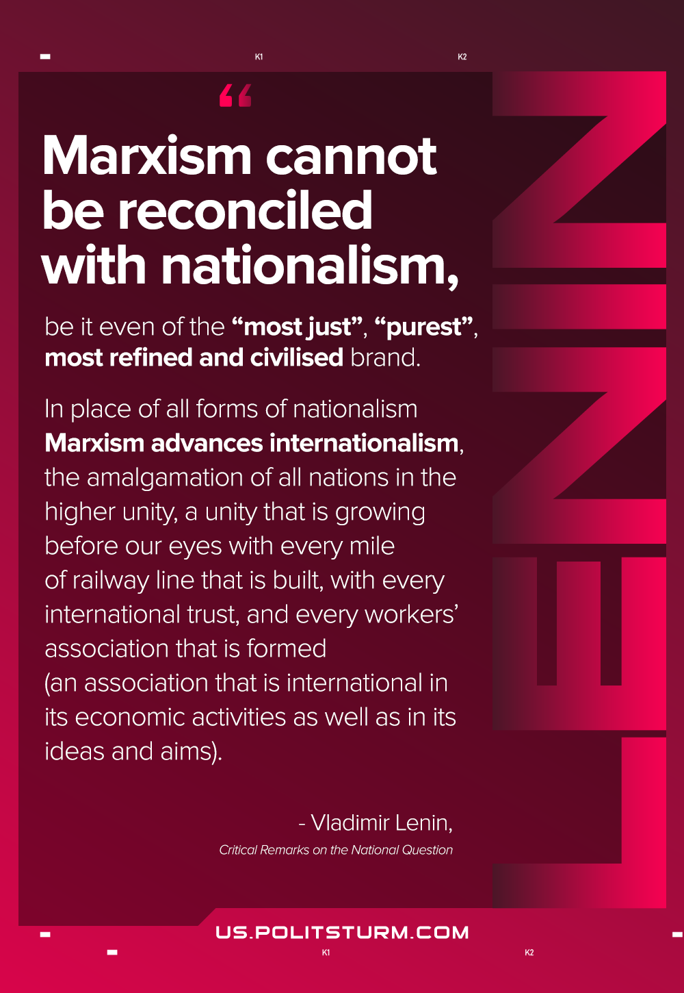

Original article
2021-03-26
1 min read

Marxism cannot be reconciled with nationalism, be it even of the “most just”, “purest”, most refined and civilised brand. In place of all forms of nationalism Marxism advances internationalism, the amalgamation of all nations in the higher unity, a unity that is growing before our eyes with every mile of railway line that is built, with every international trust, and every workers’ association that is formed (an association that is international in its economic activities as well as in its ideas and aims).
Critical Remarks on the National Question

Original article

