Lenin on Nationalism Being a Disuniting Force
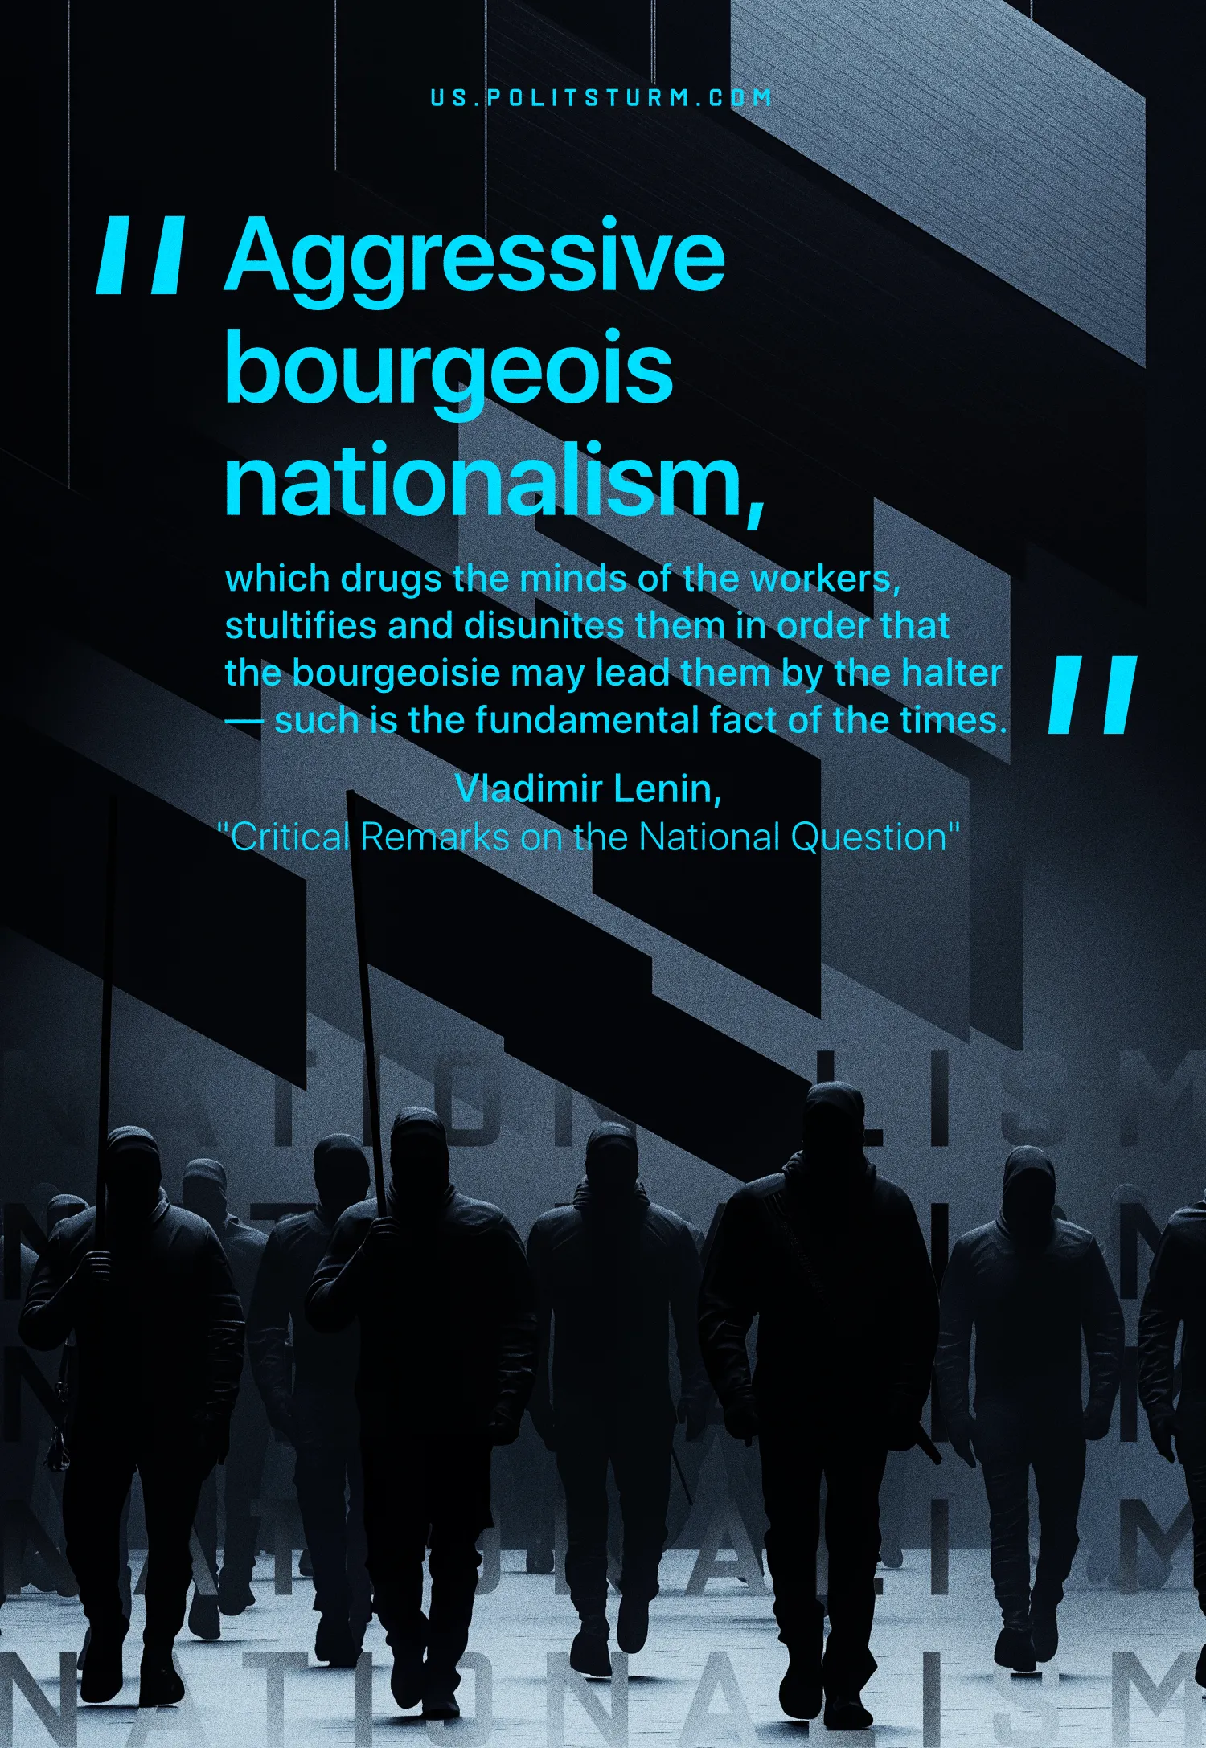

Original article
2025-02-04

“Aggressive bourgeois nationalism, which drugs the minds of the workers, stultifies and disunites them in order that the bourgeoisie may lead them by the halter — such is the fundamental fact of the times.”
Vladimir Lenin, Critical Remarks on the National Question

Original article

