Lenin on Nationalism and Internationalism
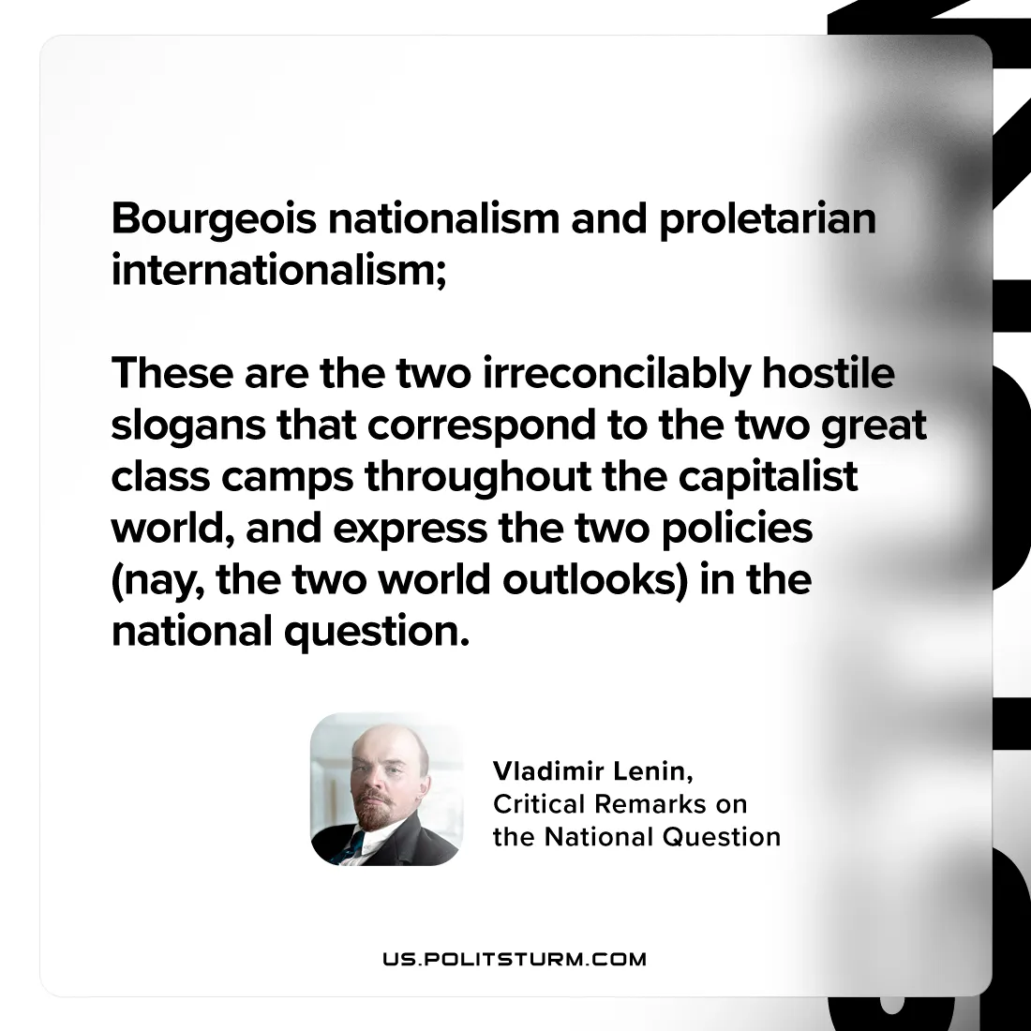

Original article
2024-08-18

"Bourgeois nationalism and proletarian internationalism—these are the two irreconcilably hostile slogans that correspond to the two great class camps throughout the capitalist world, and express the two policies (nay, the two world outlooks) in the national question.”
Vladimir Lenin, Critical Remarks on the National Question

Original article

