Lenin on Morality
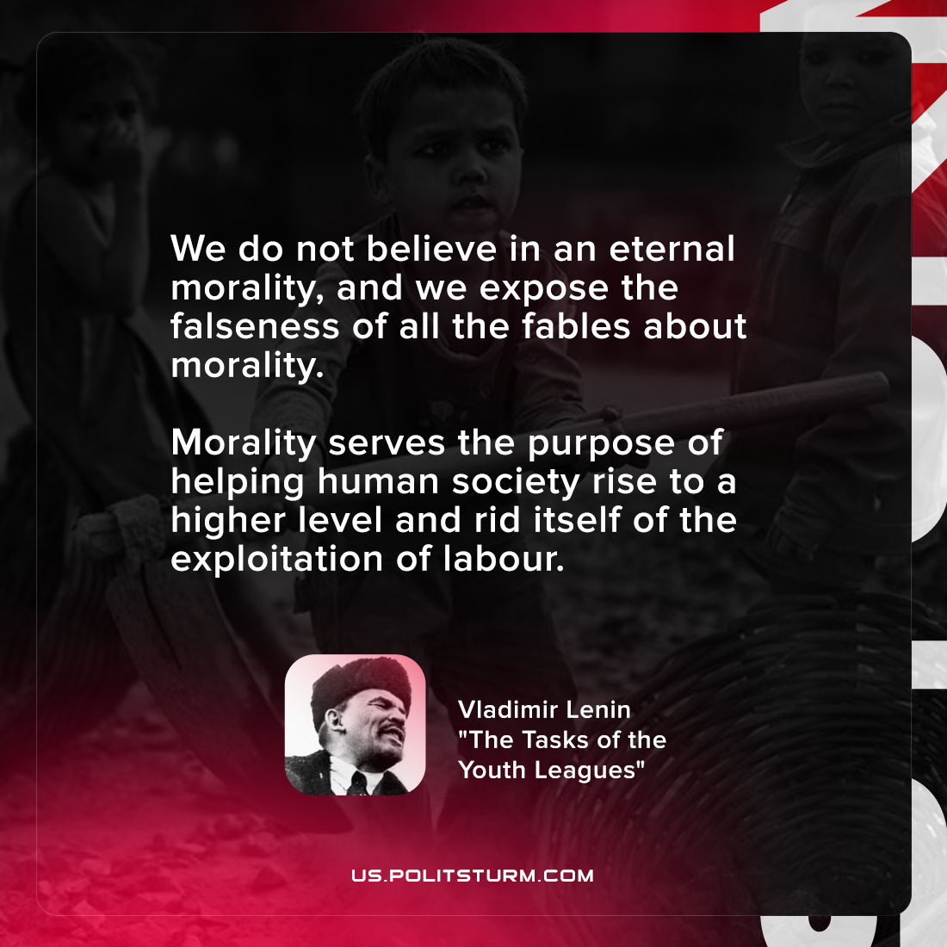

Original article
2022-03-20

We do not believe in an eternal morality, and we expose the falseness of all the fables about morality. Morality serves the purpose of helping human society rise to a higher level and rid itself of the exploitation of labour.

Vladimir Lenin, “The Tasks of the Youth Leagues”

Original article

