Lenin on Monopoly vs. Small Business
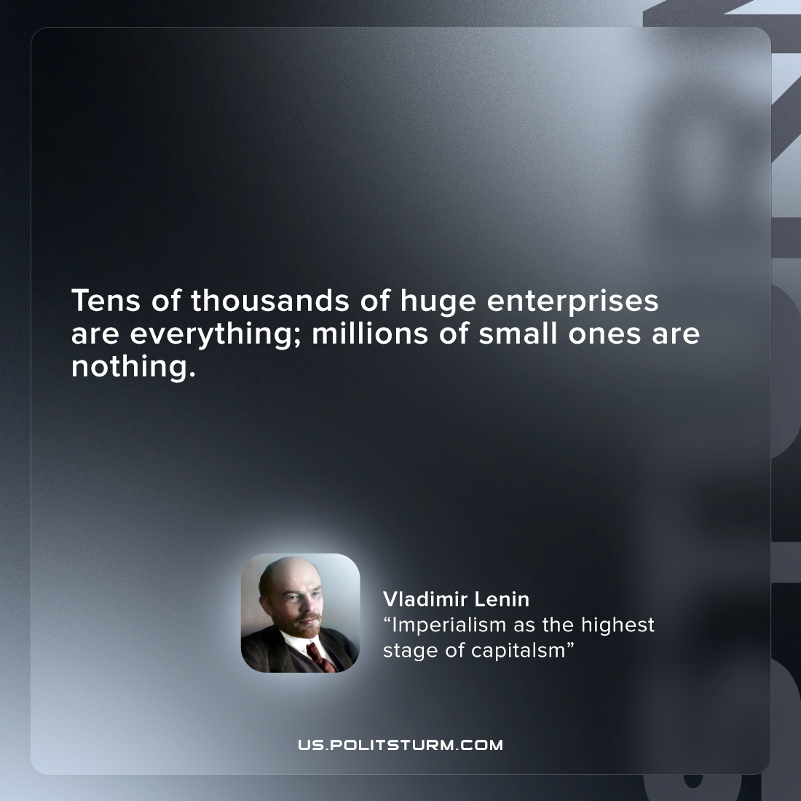

Original article
2022-07-06

Tens of thousands of huge enterprises are everything; millions of small ones are nothing.
V. I. Lenin, “Imperialism, the Highest Stage of Capitalism”

Original article

