Lenin on Monopoly
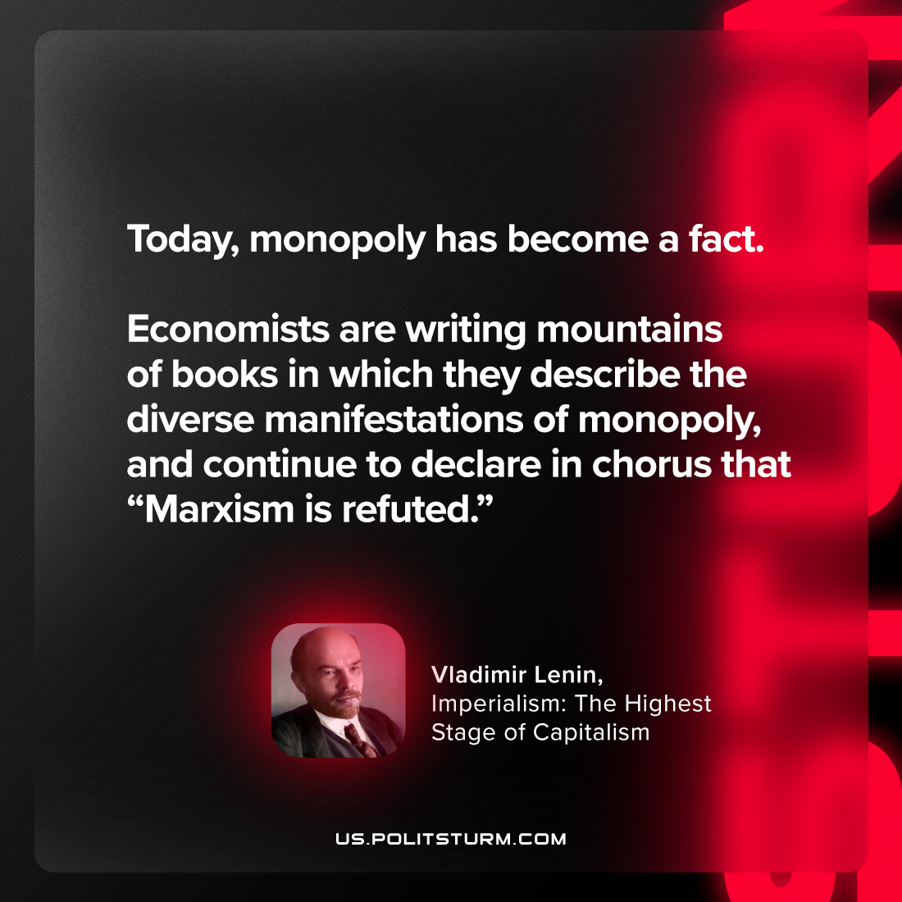

Original article
2023-09-12

"Today, monopoly has become a fact. Economists are writing mountains of books in which they describe the diverse manifestations of monopoly, and continue to declare in chorus that “Marxism is refuted.”"
Vladimir Lenin, Imperialism: the Highest Stage of Capitalism

Original article

