Lenin on Monopolism and its Favorable Representation
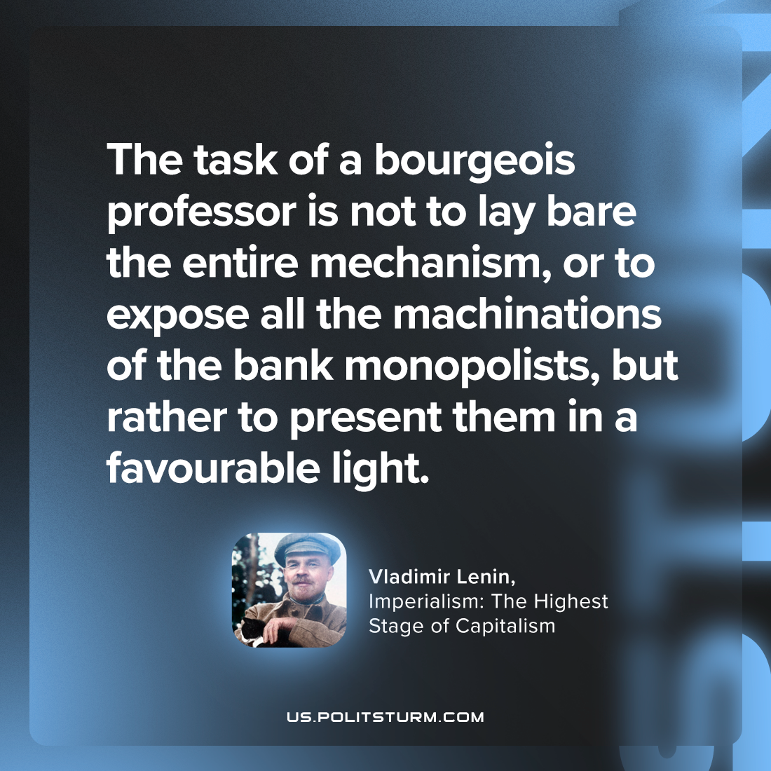

Original article
2023-09-07

"The task of a bourgeois professor is not to lay bare the entire mechanism, or to expose all the machinations of the bank monopolists, but rather to present them in a favourable light."
Vladimir Lenin, Imperialism: the Highest Stage of Capitalism

Original article

