Lenin on Monopolies
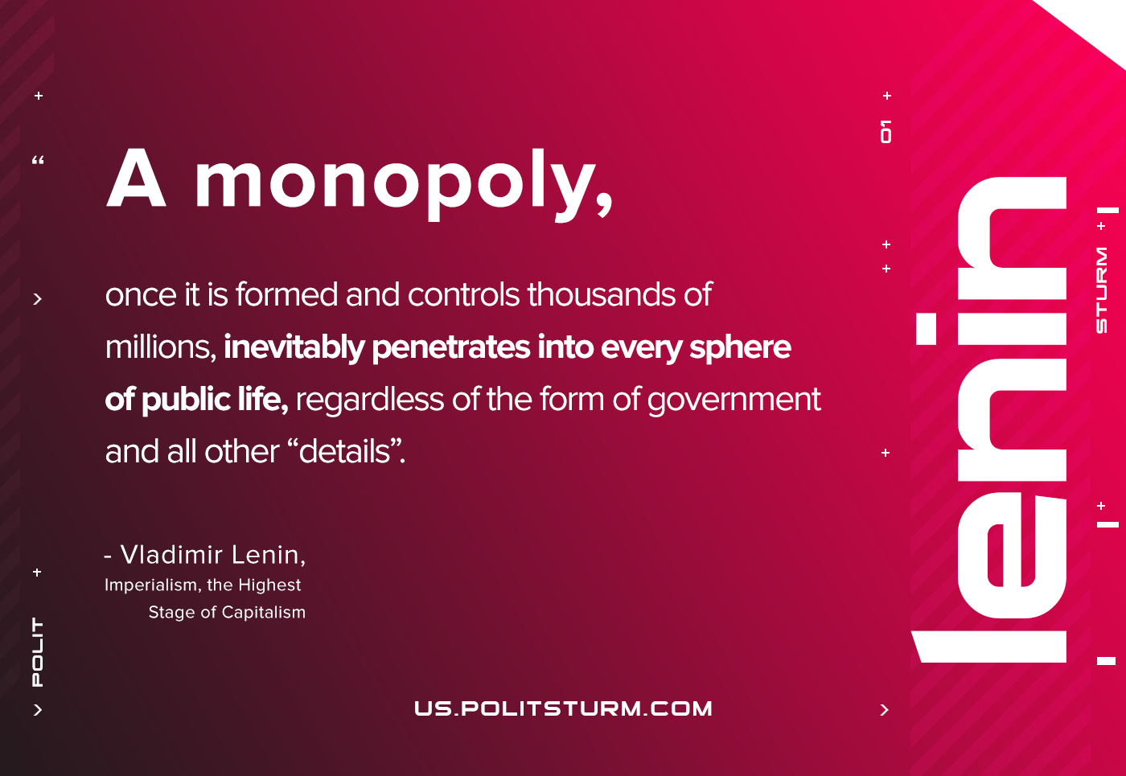

Original article
2021-02-22

A monopoly, once it is formed and controls thousands of millions, inevitably penetrates into every sphere of public life, regardless of the form of government and all other “details”.
Lenin, Imperialism, the Highest Stage of Capitalism

Original article

