Lenin on Monopolies
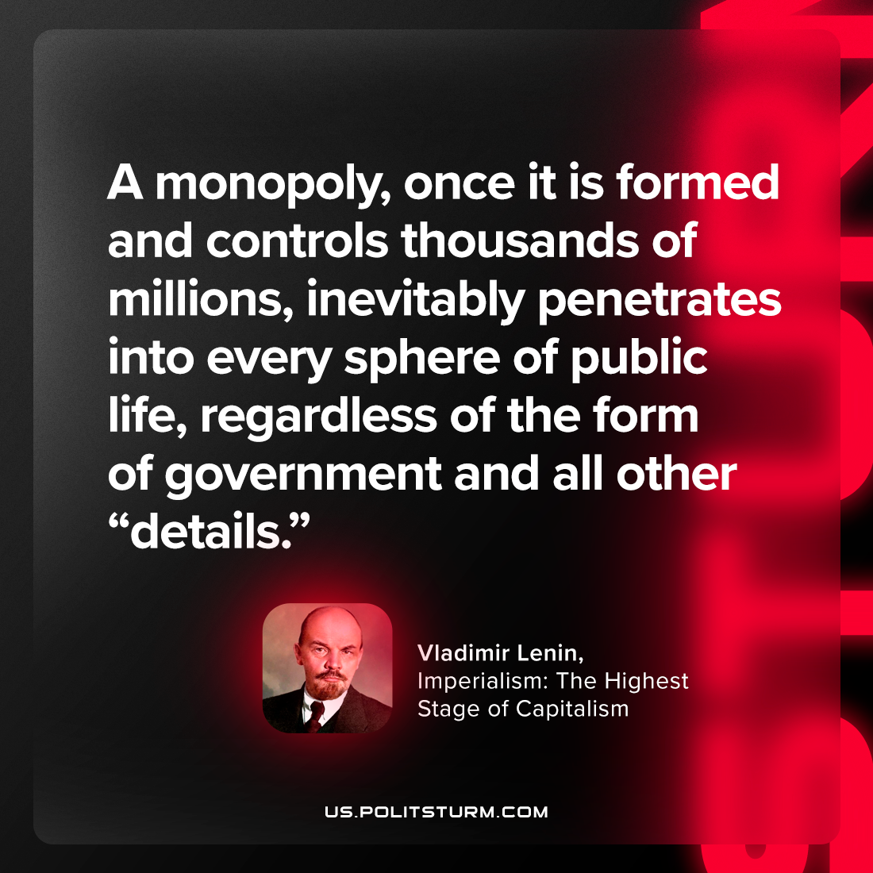

Original article
2023-10-21

"A monopoly, once it is formed and controls thousands of millions, inevitably penetrates into every sphere of public life, regardless of the form of government and all other “details.”"
Vladimir Lenin, Imperialism: the Highest Stage of Capitalism

Original article

