Lenin on Monopolies
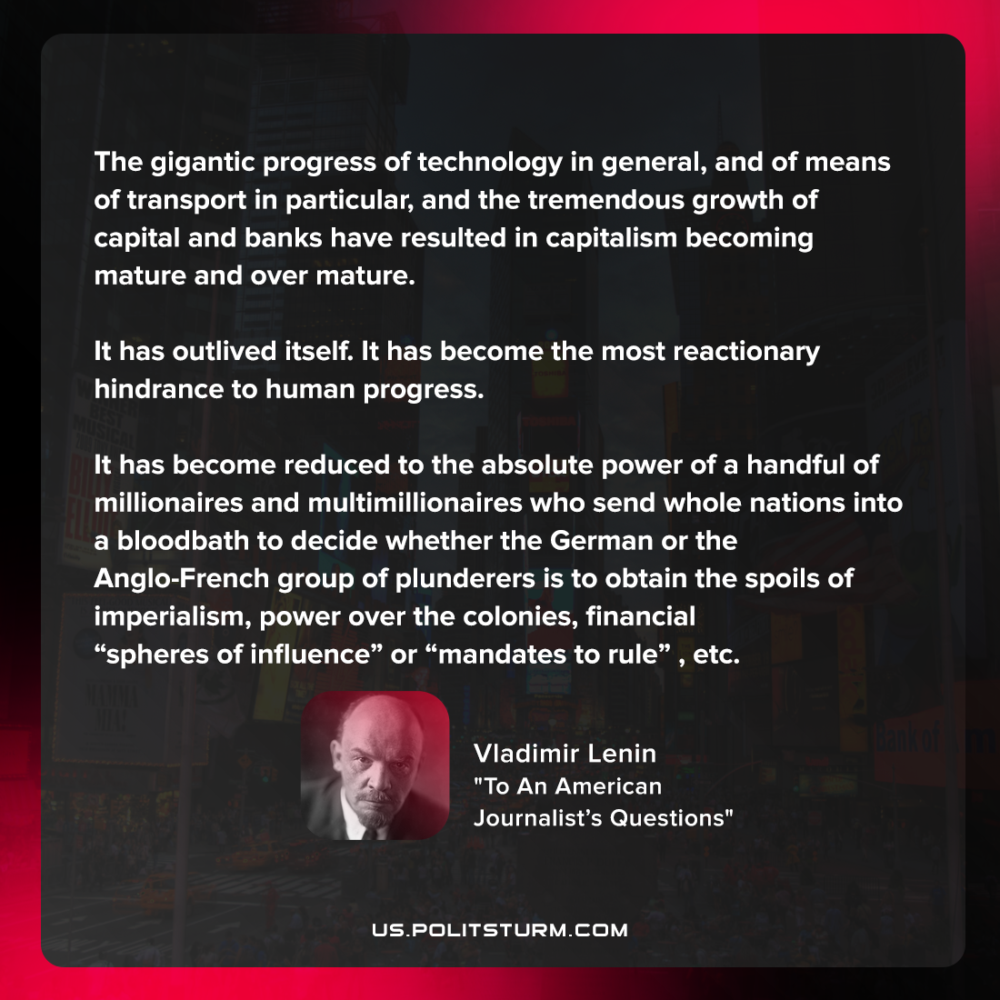

Original article
2021-10-13
1 min read

The gigantic progress of technology in general, and of means of transport in particular, and the tremendous growth of capital and banks have resulted in capitalism becoming mature and over mature. It has outlived itself. It has become the most reactionary hindrance to human progress. It has become reduced to the absolute power of a handful of millionaires and multimillionaires who send whole nations into a bloodbath to decide whether the German or the Anglo-French group of plunderers is to obtain the spoils of imperialism, power over the colonies, financial “spheres of influence” or “mandates to rule”, etc.

Vladimir Lenin, “To An American Journalist’s Questions”

Original article

