Lenin on Matter
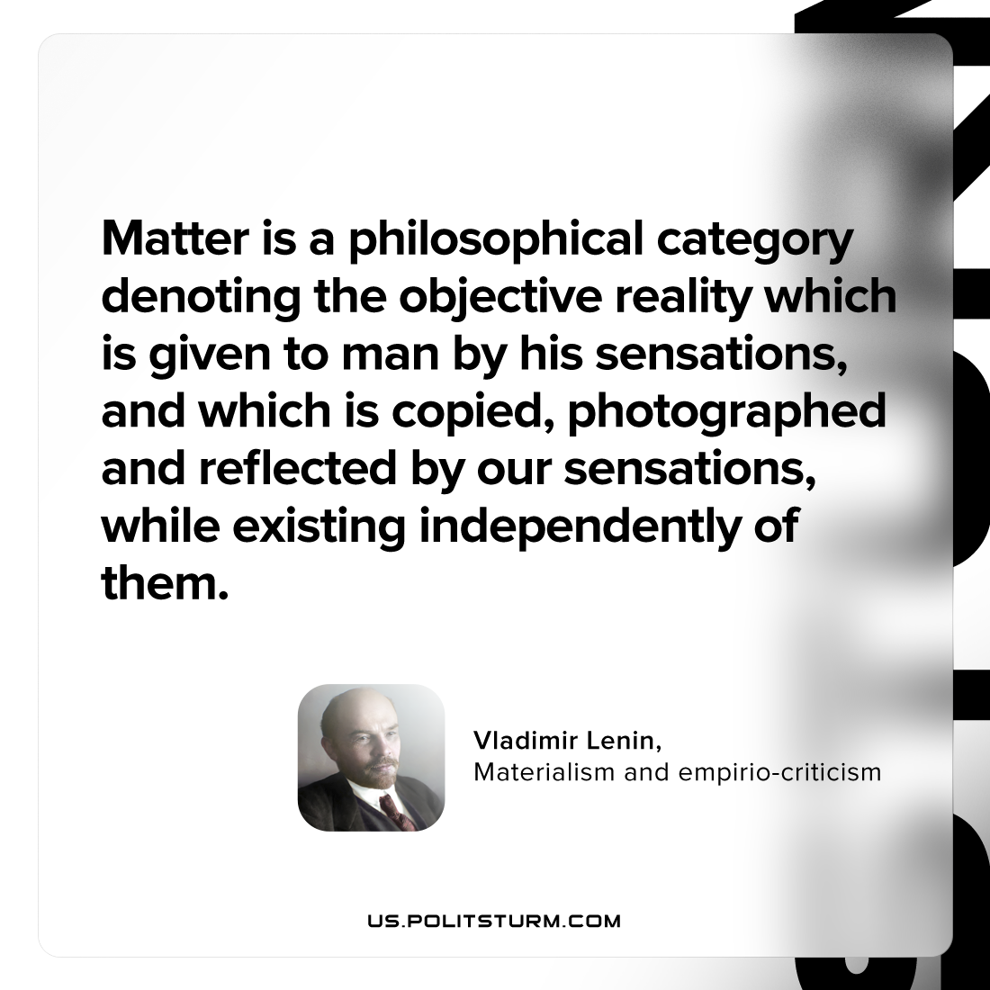

Original article
2023-07-01

"Matter is a philosophical category denoting the objective reality which is given to man by his sensations, and which is copied, photographed and reflected by our sensations, while existing independently of them."
Vladimir Lenin, Materialism and empirio-criticism

Original article

