Lenin on Marxist and Bourgeois Philosophy
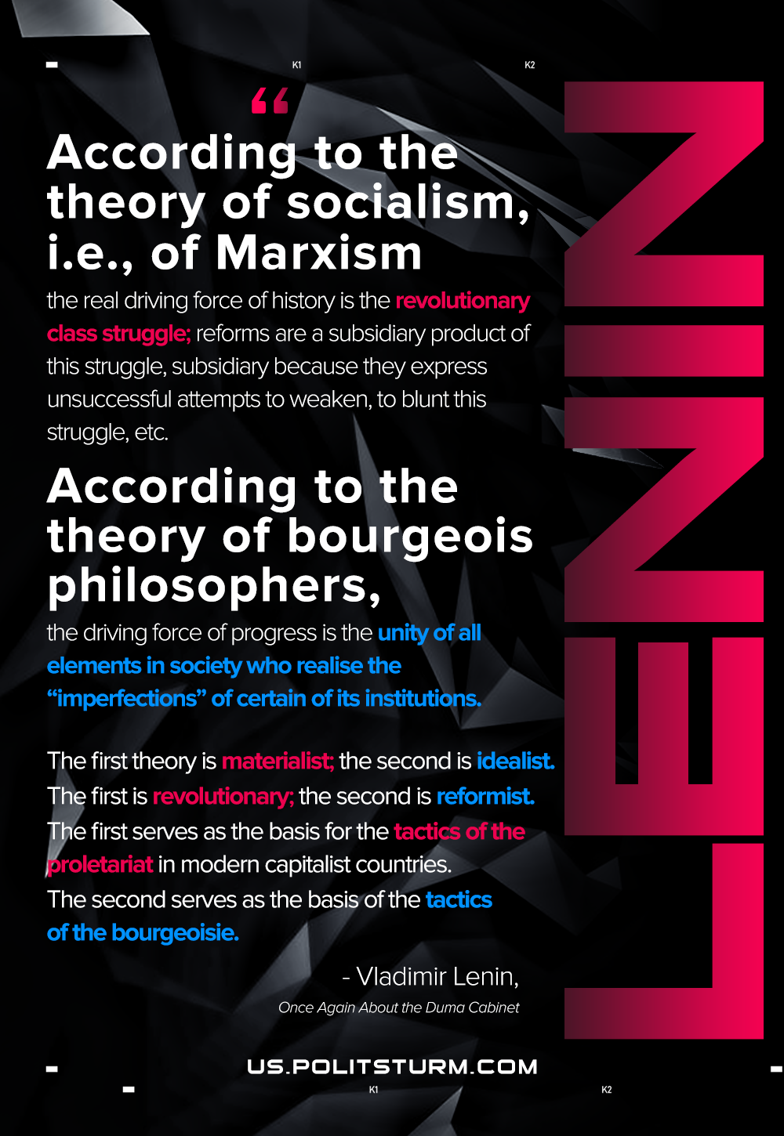

Original article
2021-01-24
1 min read

According to the theory of socialism, i.e., of Marxism (non Marxist socialism is not worth serious discussion nowadays), the real driving force of history is the revolutionary class struggle; reforms are a subsidiary product of this struggle, subsidiary because they express unsuccessful attempts to weaken, to blunt this struggle, etc. According to the theory of bourgeois philosophers, the driving force of progress is the unity of all elements in society who realise the “imperfections” of certain of its institutions. The first theory is materialist; the second is idealist. The first is revolutionary; the second is reformist. The first serves as the basis for the tactics of the proletariat in modern capitalist countries. The second serves as the basis of the tactics of the bourgeoisie.

Original article

