Lenin on Liberals and the Language Question
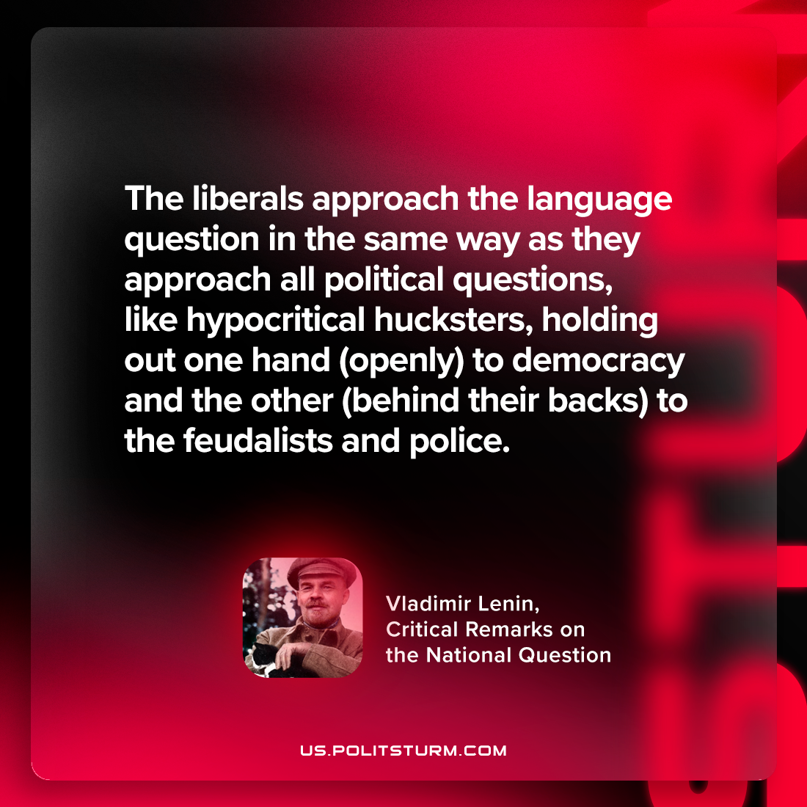

Original article
2024-07-04

"The liberals approach the language question in the same way as they approach all political questions—like hypocritical hucksters, holding out one hand (openly) to democracy and the other (behind their backs) to the feudalists and police."
Vladimir Lenin, Critical Remarks on the National Question

Original article

