Lenin on Liberal Utopias
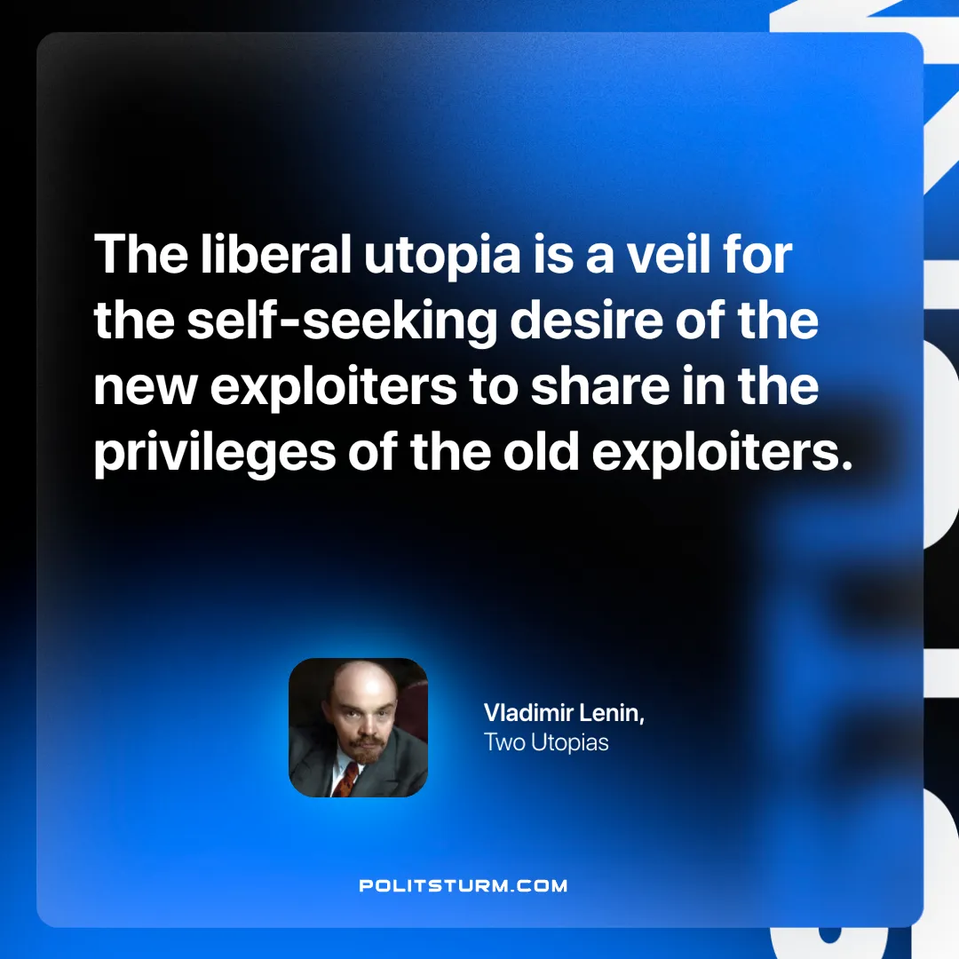

Original article
2025-03-06

"The liberal utopia is a veil for the self-seeking desire of the new exploiters to share in the privileges of the old exploiters."
Vladimir Lenin, Two Utopias

Original article

