Lenin on Liberal Bourgeois Deception
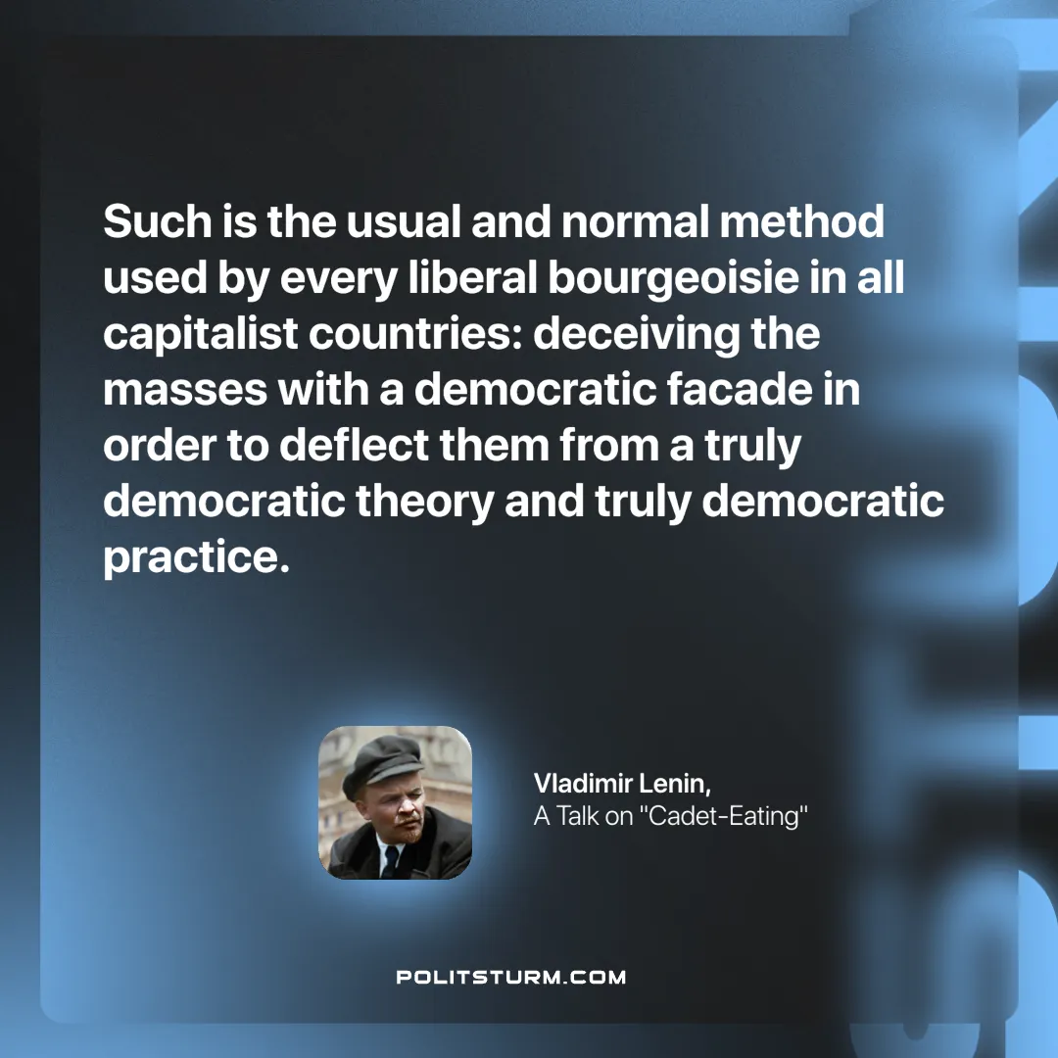

Original article
2025-03-16

“Such is the usual and normal method used by every liberal bourgeoisie in all capitalist countries: deceiving the masses with a democratic facade in order to deflect them from a truly democratic theory and truly democratic practice.”
Vladimir Lenin, A Talk on “Cadet-Eating”

Original article

