Lenin on Internationalism Needing to Struggle Against Opportunism
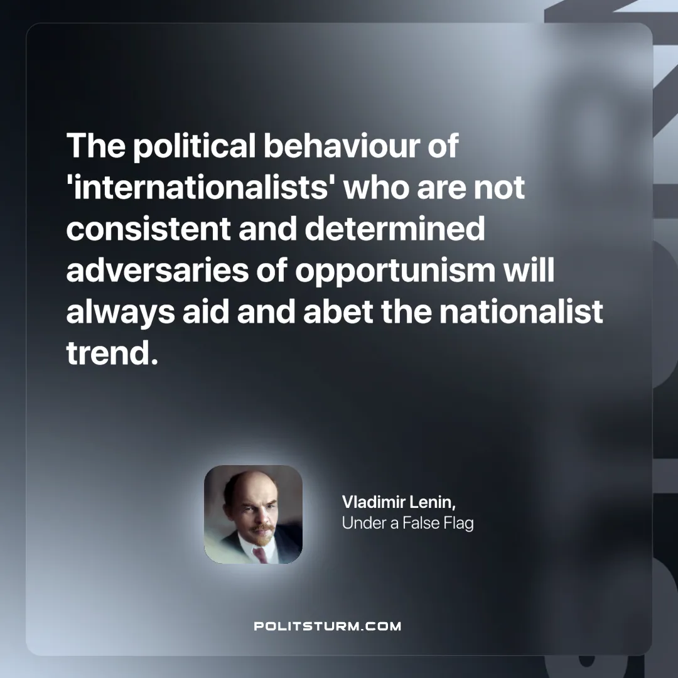

Original article
2025-03-23

"The political behaviour of 'internationalists' who are not consistent and determined adversaries of opportunism will always aid and abet the nationalist trend.
Vladimir Lenin, Under a False Flag

Original article

