Lenin on Internationalism and Chauvinism
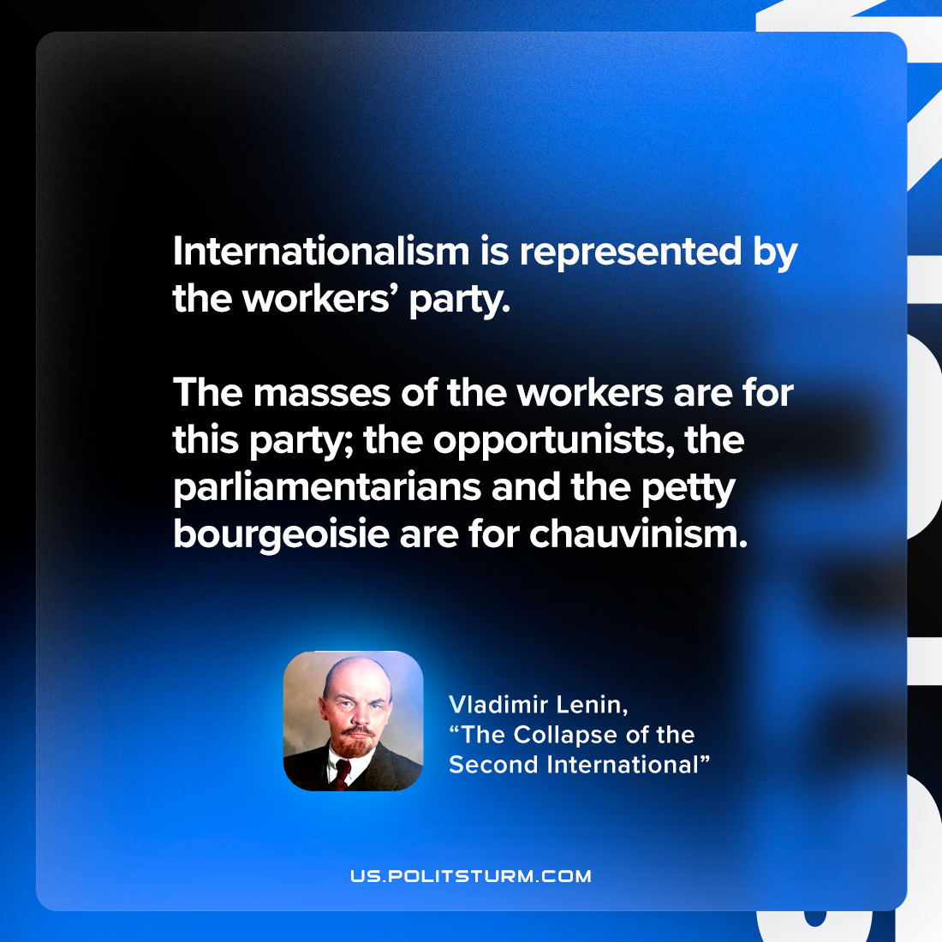

Original article
2022-12-11

"Internationalism is represented by the workers’ party. The masses of the workers are for this party; the opportunists, the parliamentarians and the petty bourgeoisie are for chauvinism."
Vladimir Lenin, “The Collapse of the Second International”

Original article

