Lenin on Inequality and Exploitation
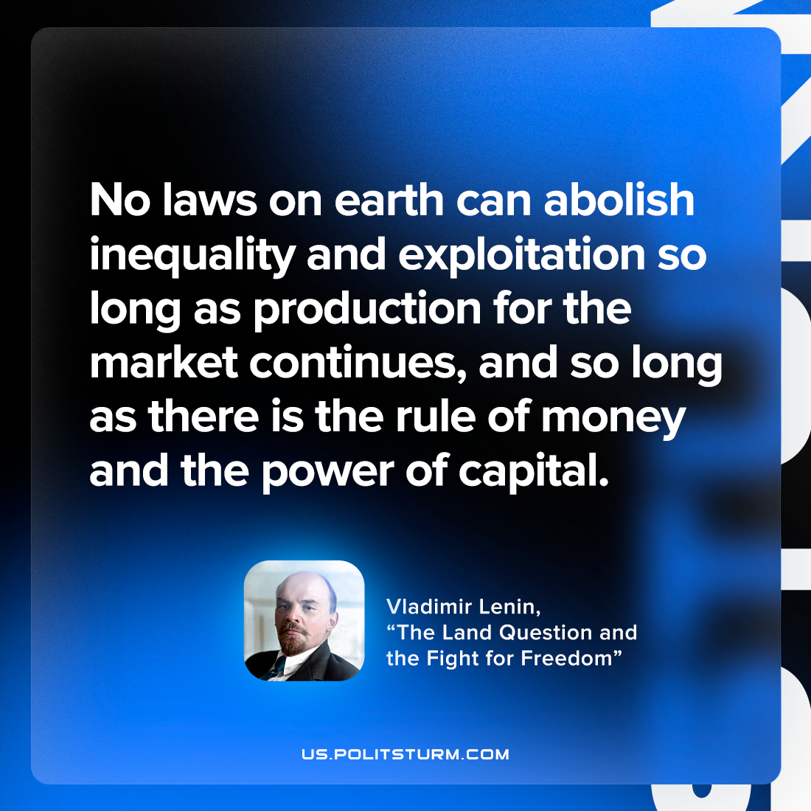

Original article
2022-08-12

No laws on earth can abolish inequality and exploitation so long as production for the market continues, and so long as there is the rule of money and the power of capital.

Vladimir Lenin, “The Land Question and the Fight for Freedom”

Original article

