Lenin on Indifference
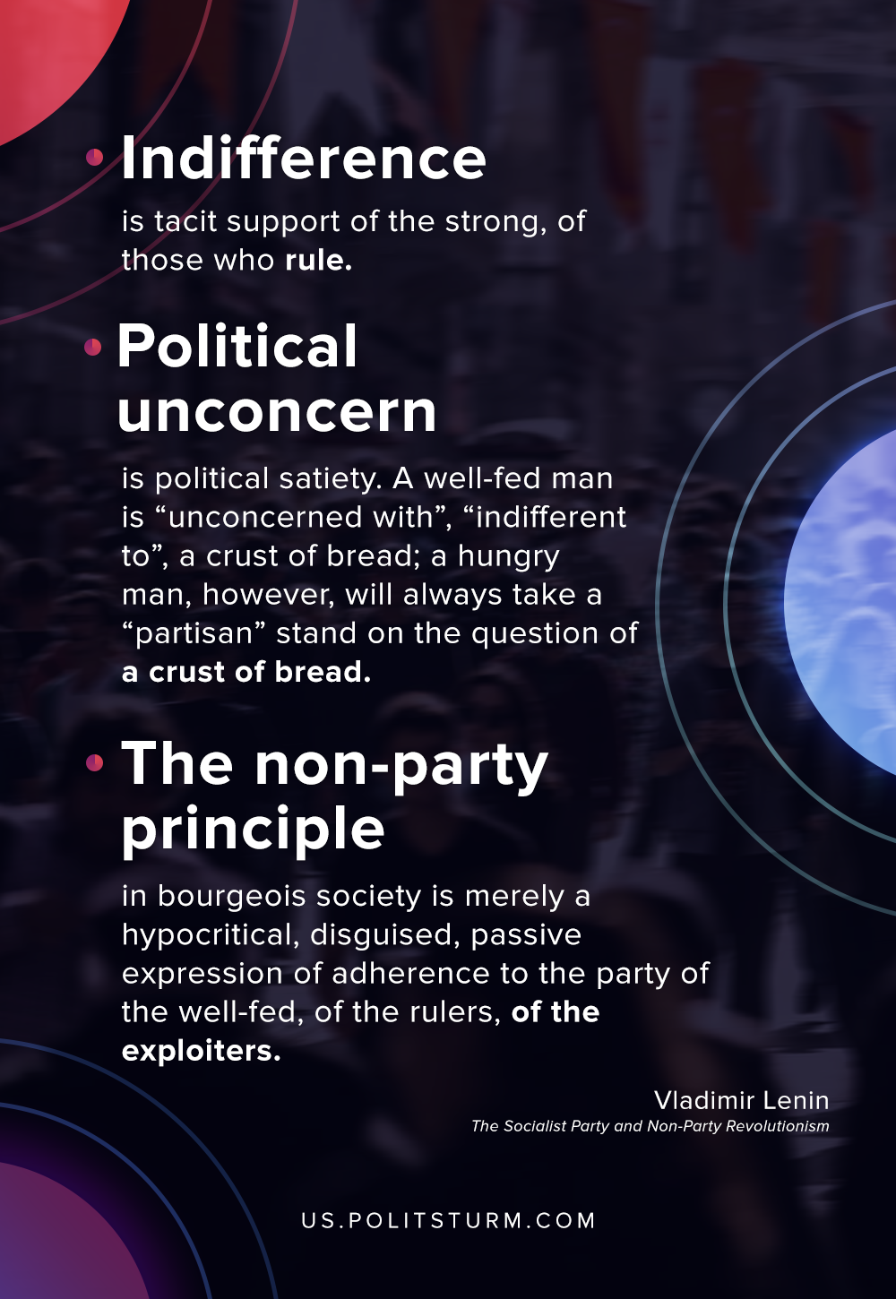

Original article
2020-08-24
1 min read

Indifference is tacit support of the strong, of those who rule. In Russia, those who were indifferent towards the autocracy prior to its fall during the October revolution tacitly supported the autocracy. In present-day Europe, those who are indifferent towards the rule of the bourgeoisie tacitly support the bourgeoisie. Those who are indifferent towards the idea that the struggle for liberty is of a bourgeois nature tacitly support the domination of the bourgeoisie in this struggle, in the free Russia now in the making. Political unconcern is political satiety.
A well-fed man is “unconcerned with”, “indifferent to”, a crust of bread; a hungry man, however, will always take a “partisan” stand on the question of a crust of bread. A person’s “unconcern and indifference” with regard to a crust of bread does not mean that he does not need bread, but that he is always sure of his bread, that be is never in want of bread and that he has firmly attached himself to the “party” of the well-fed.
The non-party principle in bourgeois society is merely a hypocritical, disguised, passive expression of adherence to the party of the well-fed, of the rulers, of the exploiters.
Vladimir Lenin, “The Socialist Party and Non-Party Revolutionism”

Original article

