Lenin on Indifference
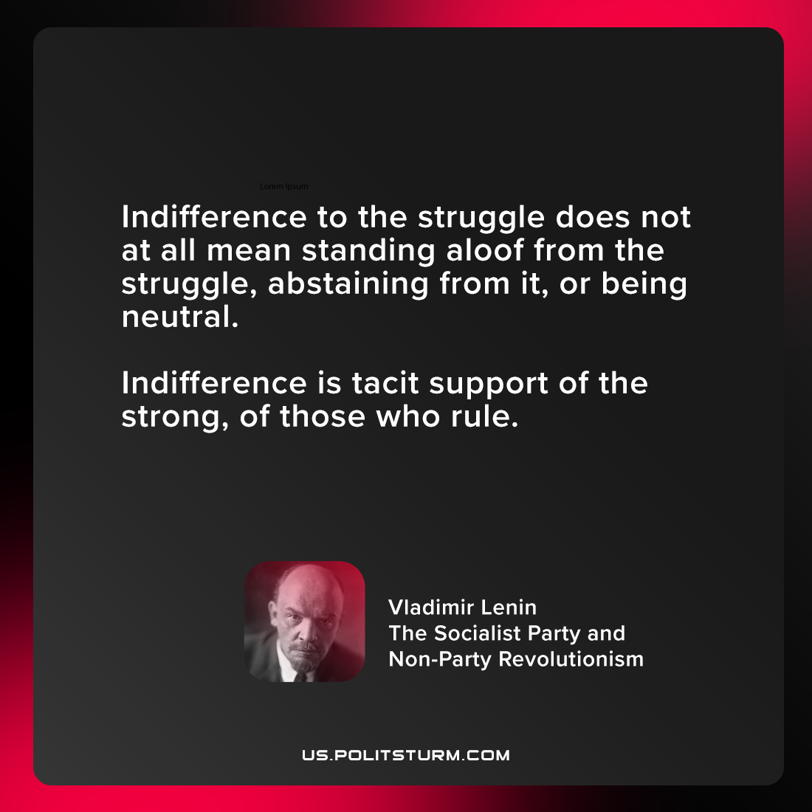

Original article
2021-08-17

Indifference to the struggle does not at all mean standing aloof from the struggle, abstaining from it, or being neutral. Indifference is tacit support of the strong, of those who rule.

Vladimir Lenin, “The Socialist Party and Non-Party Revolutionism”

Original article

