Lenin on Improvements in Productions and Workers
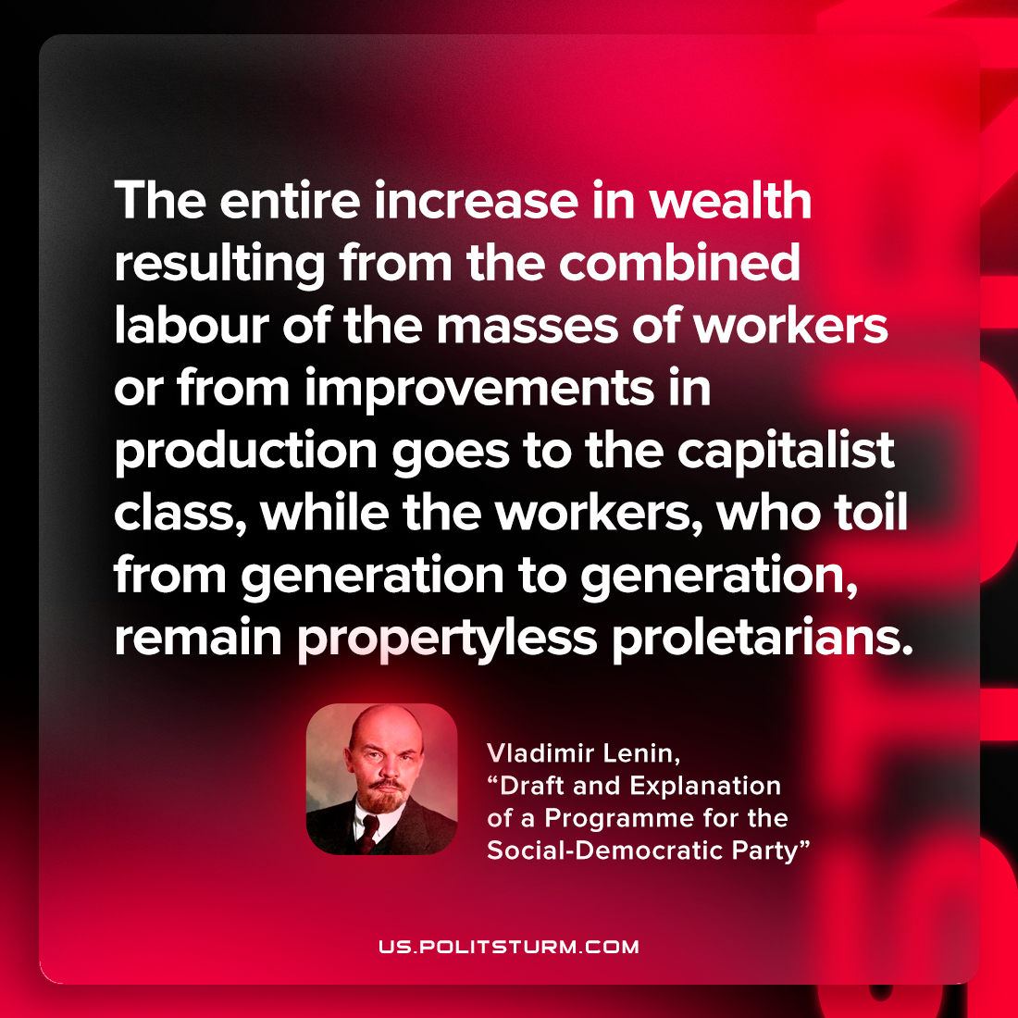

Original article
2023-05-13

"The entire increase in wealth resulting from the combined labour of the masses of workers or from improvements in production goes to the capitalist class, while the workers, who toil from generation to generation, remain propertyless proletarians."
Vladimir Lenin, “Draft and Explanation of a Programme for the Social-Democratic Party”

Original article

