Lenin on the Importance of Class
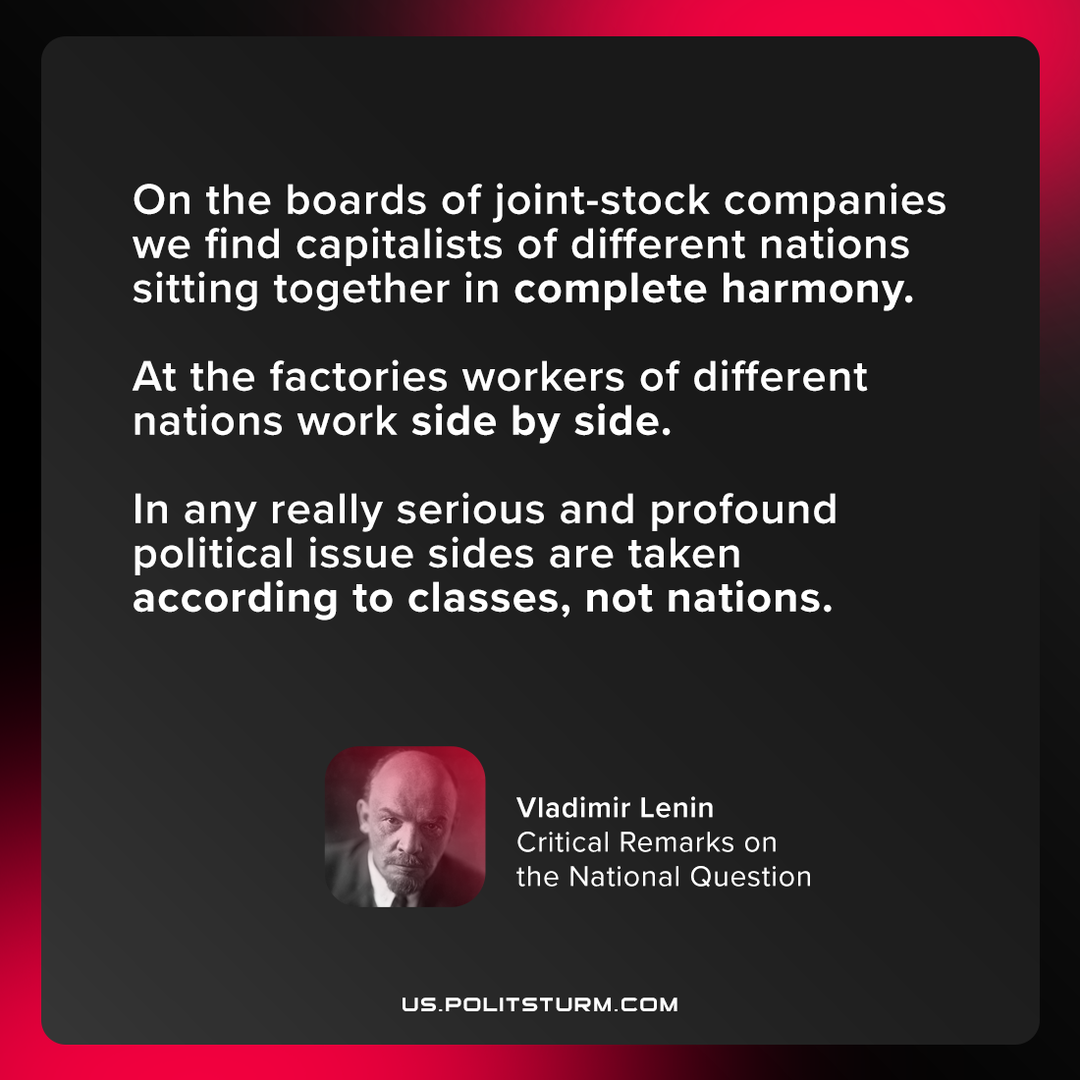

Original article
2021-07-12

On the boards of joint-stock companies we find capitalists of different nations sitting together in complete harmony. At the factories workers of different nations work side by side. In any really serious and profound political issue sides are taken according to classes, not nations.

Vladimir Lenin, “Critical Remarks on the National Question”

Original article

