Lenin on Imperialist Wars between Monopolies
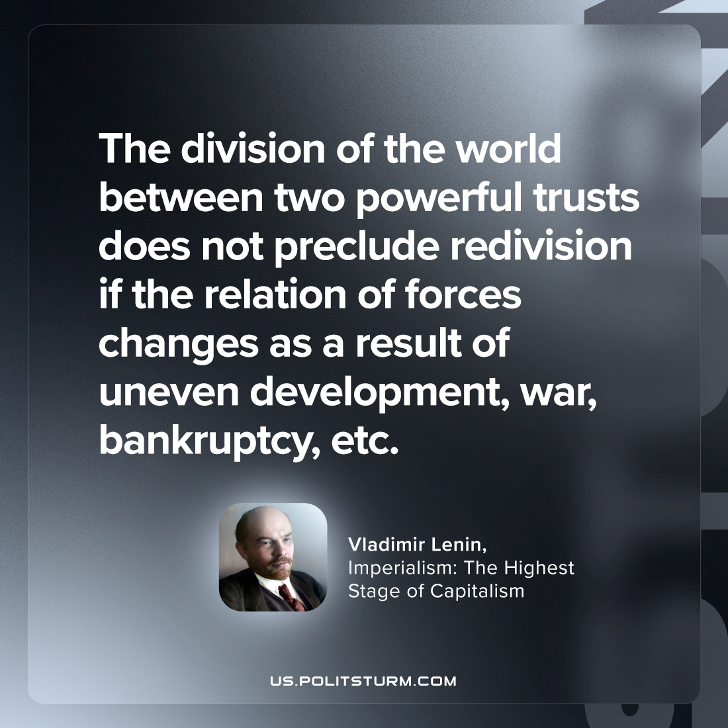

Original article
2023-10-29

"The division of the world between two powerful trusts does not preclude redivision if the relation of forces changes as a result of uneven development, war, bankruptcy, etc."
Vladimir Lenin, Imperialism: the Highest Stage of Capitalism

Original article

