Lenin on Imperialist "Internationalism"
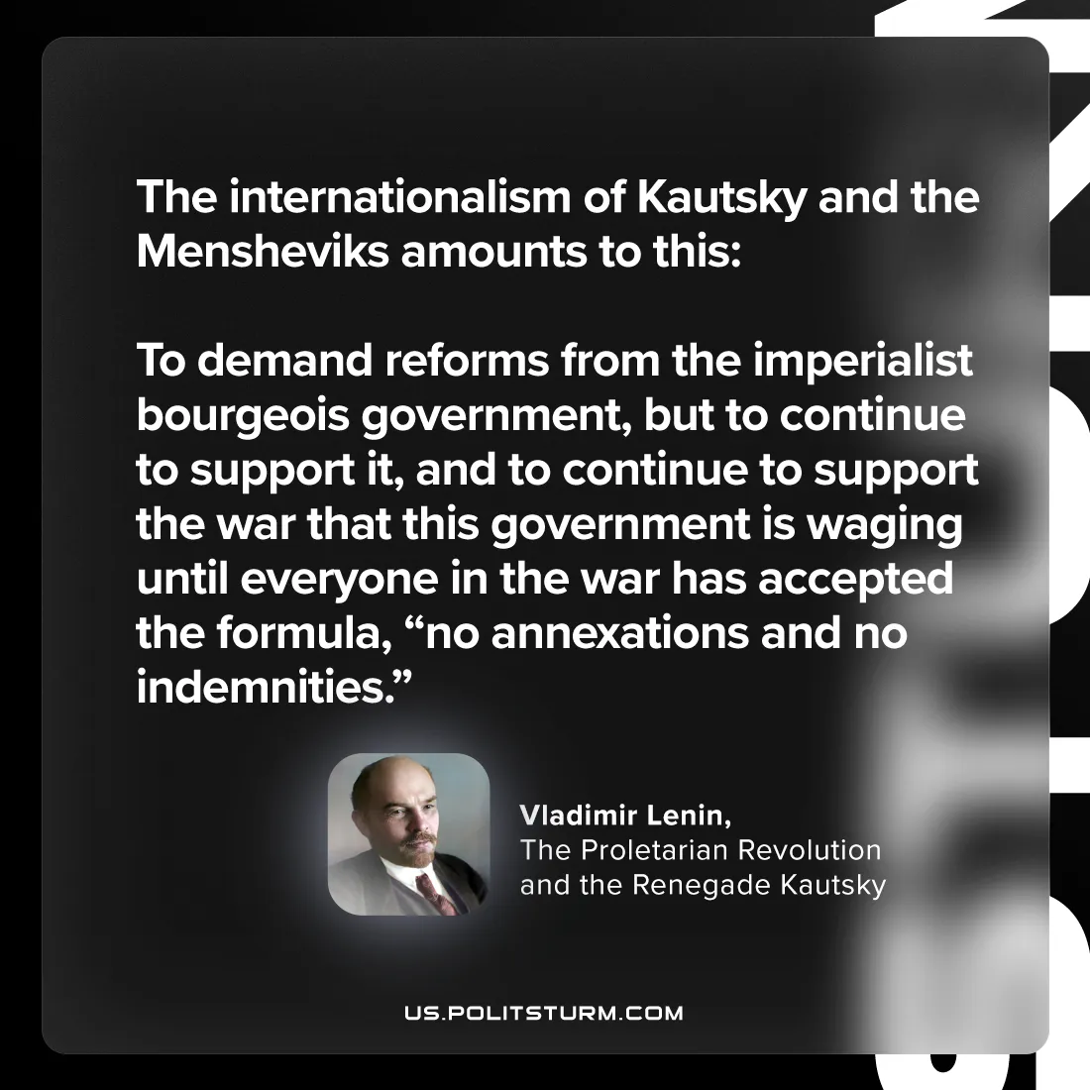

Original article
2024-08-20

"the internationalism of Kautsky and the Mensheviks amounts to this: to demand reforms from the imperialist bourgeois government, but to continue to support it, and to continue to support the war that this government is waging until everyone in the war has accepted the formula: no annexations and no indemnities.”
Vladimir Lenin, The Proletarian Revolution and the Renegade Kautsky

Original article

